

***The Arab American University***

***Faculty of Engineering and Information Technology***

***Senior Project II Report***

***Portable ECG Monitoring and Analysis System***

***By:***

***Abdulsalam Mustafa Mansour***

***Ali Mohammad Sawahreh***

***Mokhles Basim Naghnagheah***   
 

***Supervisor:***

***Dr. Rami Hodrob***

   
   
   
 

***Date:***

***14- Jan- 2019***

Table of Contents

Declaration 5

Abstract 6

List of Tables 7

List of Figures 8

List of Abbreviations 10

Acknowledgements 11

Chapter One: Introduction 12

1.1 Background and Motivation 12

1.2 Aims and Objectives 12

1.3 Problem Statement 13

Chapter Two: Literature Review 14

2.1 Overview 14

2.2 Existing Systems 14

2.2.1 The Wearable Electronic Rescue System for Home Alone Elderly-Lab View & Arduino Evaluation. 14

2.2.2 Smartphone Integration 15

2.2.3 Real Time ECG Feature Extraction and Arrhythmia Detection on a Mobile Platform 16

2.2.3 Mobile Health System for Monitoring ECG signals 16

2.2.4 AliveCor 18

2.2.5 Body Guardian Heart 18

2.2.6 QardioCore 19

2.2.7 CardioSecur 20

2.2.8 SHL Telemedicine 21

2.2.9 Apple Watch Series4 21

2.3 Summary 22

Chapter Three: System Analysis 23

3.1 Introduction 23

3.2 Analysis of Existing Systems 23

3.2.1 Document Review 23

3.2.2 Data Collection Tools 23

3.2.3 Users Interviews & Observations 24

3.3 System Requirements 25

3.3.1 Functional Requirements 25

3.3.2 Non Functional Requirements 25

3.4 Design Objectives 26

3.4.1 User Requirements 26

3.4.2 System Architecture 27

3.5 Development Methodology 27

3.5.1 Use Case Diagrams 28

3.5.2 Use Case Description (Detailed Use Cases) 28

3.5.3 Sequence Diagram 30

3.6 Summary 31

Chapter Four: System Design 32

4.1 Introduction 32

4.2 Class Diagram 32

4.3 Data base Design 33

4.4 Algorithms 34

4.5 Interface Design 36

4.6 Hardware 37

4.6.1 Hardware Components 37

4.7 Summary 39

Chapter Five: Evaluation and Results 40

Chapter Six: Conclusions and Future Work 43

6.1 Conclusions 43

6.2 Future Work 43

References 44

Appendices 45

Appendix A: ECG Basics and Rhythm Interpretation 45

Appendix B Business Plan 48

Appendix B.1 Executive Summary 48

Appendix B.2 Product 49

Appendix B.3 Market Analysis 50

Appendix B.4 Strategy and Implementation 59

Appendix C: Market Research 64

Appendix C .1 Data Collection Tools 64

Appendix C .2 Interviews Implementation 64

Appendix C .3 Interviews Results 64

Appendix C.4 Interviews’ Questionnaires 65

Appendix D: Financial Plan 68

Appendix E: Code & Results 68

# Declaration

This is to declare that the graduation project entitled (Portable ECG Monitoring and Analysis System) under the supervision of (Dr. Rami Hodrob) is our own work and does not contain any unacknowledged work or material previously published or written by another person, except where due reference is made in the text of the report.

Date: 14- Jan- 2019

Graduation project’s students:

Name:  Signature:

Abdulsalam Mansour

Name:  Signature:

 Ali Sawahreh

Name:  Signature:

 Mokhles Naghnagheah

# Abstract

Early detection of arrhythmia can save many people lives, the main idea of the work is to measure the ECG signal using Healthy-pi HAT, the device measures vital signs and ECG. The signal well be measured using Raspberry-pi, then it will be sent to a server to be analyzed. Data will be stored in a database for future reference.

The system will have two views of data, the first view is an android application that will be used by the patient, the second view is a web application that will be used by the specialist.

In addition, the system will notify the closest medical center in case of the patient's sudden health deterioration, an SMS will be sent automatically with the patient’s location based on GPS.

The process of analyzing the ECG signal is based on extracting its features, this well be performed by reading the P-wave, QRS-complex and T-wave, these are the three main waves that ECGs consist of, and many of arrhythmia diagnosing is based on its values.

# List of Tables

Table 5. 1 NSR average peaks 41

Table 5. 2 AFib average peaks. 42

Table B. 1 Competitors Analysis 56

Table B. 2 Mile Stones & Outline. 60

Table B. 3 Management Team 62

Table B. 4 Employees. 63

# List of Figures

Figure 2. 1 The Wearable Electronic Rescue System for Home Alone Elderly-Lab View & Arduino Evaluation ECG signal processing flow chart[3]. 15

Figure 2. 2 Real Time ECG Feature Extraction and Arrhythmia Detection on a Mobile Platform architectural design[5]. 16

Figure 2. 3 Mobile Health System for Monitoring ECG signals architectural design[6]. 17

Figure 2. 4 AliveCor System[8] 18

Figure 2. 5 Body Guardian System[9] 19

Figure 2. 6 QradioCore System.[10] 19

Figure 2. 7 CradioSecur System.[11] 20

Figure 2. 8 Smartheartpro System.[12] 21

Figure 2. 9 Apple’s ECG app.[13] 22

Figure 3. 1 Architectural design 27

Figure 3. 2 Waterfall mode, progress flows from the top to the bottom. 27

Figure 3. 3 Use case diagram 28

Figure 3. 4 Doctor’s use case description 28

Figure 3. 5 Patient's use case description 29

Figure 3. 6 ECG analysis use case description 29

Figure 3. 7 Detect defects 30

Figure 3. 8 Feature extraction 30

Figure 3. 9 Read vital signs 30

Figure 3. 10 View vital signs 31

Figure 3. 11 Emergency Message 31

Figure 4. 1 System Class Diagram. 33

Figure 4. 2 System Database. 34

Figure 4. 3 Sample wave. 35

Figure 4. 4 QRS detection NSR. 35

Figure 4. 5 P, QRS & T Peaks Detection NSR 35

Figure 4. 6 Web Client interface. 36

Figure 4. 7 MobileApp Interface 36

Figure 4. 8 Raspberry-Pi 3 Model B. 38

Figure 4. 9 Raspberry-Pi Models Comparison Table 38

Figure 4. 10 Heakthy-Pi Module. 39

Figure 4. 11 Vital signs from Healthy-Pi HAT 39

Figure 5. 1 NSR 3 peaks detection 41

Figure 5. 2 NSR 4 peaks detection 41

Figure 5. 3 AFib 0 Peaks Detection. 42

Figure 5. 4 AFib 2 Peaks Detection 42

Figure A. 1 Normal ECG Wave and Intervals 45

Figure A. 2 Representation of the meaning of each wave in ECG. 46

Figure A. 3 AFib ECG 47

Figure A. 4 Comparison Between Regular Rhythm & Atrial Fibrillation 47

Figure B. 1 Porter’s Five Forces Model 58

Figure B. 2 Organizational Structure. 63

# List of Abbreviations

**Cardiovascular Disease (CVD):** a class of diseases that involve the heart or blood vessels.

**Electrocardiogram (ECG):**  the process of recording the electrical activity of the heart over a period of time.

**Internet of Thing (IoT):** the network of devices.

**Arrhythmias:** a condition in which the heart beats with an irregular or abnormal rhythm.

**Atrial Fibrillation (AFib):** a heart arrhythmia.

**SoC:** System on chip.

**MIT:** Massachusetts Institute of Technology.

# Acknowledgements

Thanks to Almighty Allah who made it easy for us to complete this project. This work would not have been possible without the supervision and support of Dr. Rami Hodrob who was with us from the beginning, we are also grateful for all of our instructors who have provided personal and professional guidance throw all of our college life.

Nobody has been important to us in the pursuit of this project more than the members of our families and friends. We would like to thank our parents; whose love and guidance are with us wherever we pursue.

Not to forget to say thanks for EIT College and the AAU where we learned and added to our knowledge and for giving us the chance to be part this great family.

# Chapter One: Introduction

## Background and Motivation

The Cardiovascular Disease (CVD) is one of the leading causes of death around the world, “Due to the changing lifestyle, heart attack rate is increasing day by day. In India, current heart attack rate is about 25%”[1].

This phenomenon increases the need for a reliable, low cost, portable and accurate system to foresee the symptoms of CVD before it’s too late; the current technological advancements provided us with a collection of very useful devices that can be used to implement a portable system to monitor the vital signs which are linked to widely spread heart diseases.

The main idea of our system revolves around using Internet of things (IOT) to collect and analyze data in real time to foresee the possibility of a heart related disease.

One of the most useful indicators for heart related problems is the Electrocardiogram (ECG), “Early detection of arrhythmic beats in the electrocardiogram (ECG) signal could improve the identification of patients at risk from sudden death, for example due to coronary heart disease” [2].

## Aims and Objectives

Our aim is to measure ECG signal and process it in real time using Raspberry pi 3 microcontroller and a server, the processing stage shall include comparing the ECG of the patient to a database of ECG signal variations that indicates several heart problems, using this comparison the system will determine the problem if present and will notify the patient and his physician, this process can save the life of many people because traditional health monitoring devices are very expensive and requires the patient’s attendance in a medical center.

Many people can take advantage of such system, especially in developing countries where medical centers are not equipped to handle large numbers of people for prolonged periods of time, a patient with minor symptoms can be sent home with this device to make sure any further health complications will be handled in time.

A great advantage of a health system based on IoT is the possibility of collecting data for multiple patients simultaneously, the gathered data can be sent to a web server to enable a specialist to look at the readings for the patients, which would enable him to handle more patients than he would with the use of traditional systems.

Another group of people can take advantage of such system, people who take care of an old family member, old people require constant monitoring of health metrics because they are usually prone to heart diseases, which makes constant health monitoring a must, such system can help these people have a peace of mind.

## Problem Statement

In most cases where death is caused by a CVD, late diagnosis is the main reason why doctors can’t help the patient. Our system aims to the early detection of CVD symptoms, which can make a lot of difference in patient treatment and recovery.

# Chapter Two: Literature Review

## Overview

In this section we are going to present systems that are similar to our system. However, some of the systems may offer some extra or irrelevant features, but the core of all discussed systems is the analysis of the ECG signal.

Each system has its own advantages and disadvantages, for example most of the discussed systems use relatively old hardware, our system takes advantage of the processing power of the raspberry pi and modern smartphones, newer hardware means better accuracy and more reliability.

The most important differentiation between these systems is that some of them only gather the raw signal without feature extraction and processing, and some other has the capability of processing the signal to give meaningful information.

## Existing Systems

### The Wearable Electronic Rescue System for Home Alone Elderly-Lab View & Arduino Evaluation.

This system is dedicated for home alone elderly and it’s used to detect if there are any heart issues or if the patient’s body has fallen, the system sends information to the doctor via cellphone SMS, and it’s developed using Arduino & GSM module. In case of up normality in the electrocardiogram and the body vibration signals, the system sends an alert to predefined intended people or centers.

Methods & materials: -

This system is divided into three main parts which are the ECG signal acquisition and analysis, sudden fall signal acquisition and analysis and Text message handling process.

1. ECG signal acquisition and analysis: This part of the system is responsible for the graphical output of the bioelectric potential and electro conduction system of heart, Arduino is used to interface to computer. After reading the ECG signals and eliminating all the noise from it via Advance Signal Processing toolkit -ASPT-, the processed data is used by biomedical toolkit to determine if there is any abnormality in the signal.
   1. Sudden fall signal acquisition and analysis: using the angular placement of an accelerometer parallel to standstill human prototype to detect if the situation of the body.
   2. Text message handling process: When any of the measured signals goes beyond abnormal the GSM sends appropriate text message to a particular cell phone number. [3]

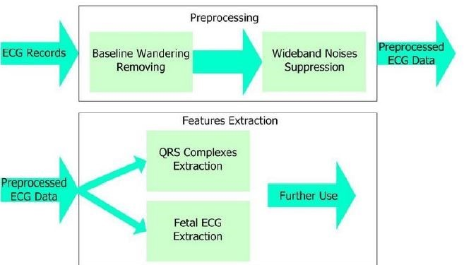

Figure 2. 1 The Wearable Electronic Rescue System for Home Alone Elderly-Lab View & Arduino Evaluation ECG signal processing flow chart[3].

### Smartphone Integration

Nowadays, many companies and vendors are adding smart phone interoperability to their systems, in our project, we intend to make ECG wave forms available for cardiologists anywhere, this rapid integration of smartphones into other systems will allow earlier diagnoses, leading to better patient treatment in many cases, this integration of smartphone will be very helpful to cardiologists who are not near an ECG system workstation, or at home in off-hours.

Here are some examples of companies that implemented the previous integration:

1. SCL-mage presented its browser-based ECG delivery utility to give immediate access to raw ECG waveforms integrated into smartphones and websites.
2. Some Healthcare facilities in San Antonio, Texas, are using a management system to make pre-hospital and emergent electrocardiograms (ECGs)  immediately available to specialists.
3. A company called Lumedx-Healthview has developed a chest pain management system that makes ECG waveforms immediately available to cardiologists, and then these specialists will use these waveforms to compare them with other previous ECGs. The system provides historical clinical information related to other disparate systems and assemble them into a single dashboard view available anywhere, anytime to cardiologists with an internet connection. [4]

### 2.2.3 Real Time ECG Feature Extraction and Arrhythmia Detection on a Mobile Platform

The system was developed for the detection of abnormal rate of heart contraction using ECG signal & smart phone. This system has 97.3% accuracy detecting abnormal heart contraction which makes it helpful in medical diagnosis; users of the system have real time access to the information via a SMS, MMS or email.

1. System Architecture: the system is composed of three parts: the sensor part, the mobile part and the server part.
2. Sensor part: wearable ECG sensor used to sense the data and record the patient ECG signals. The recorded data transferred wirelessly to mobile via Bluetooth.
3. Mobile part: performs seven main functions which are ECG Signal Acquisition, ECG signal Filtering, Measuring Important physical parameters of ECG signal, Arrhythmia Detection, Graphical User Interface (GUI), Save record of Patients in database and Wireless Transmission to Server.
4. Server part: Store the record of all patients so it can be retrieved when needed. [5]

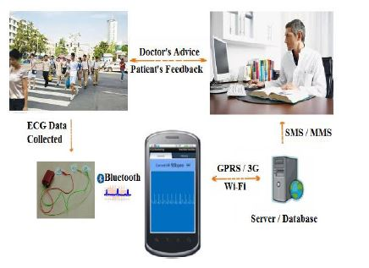

Figure 2. 2 Real Time ECG Feature Extraction and Arrhythmia Detection on a Mobile Platform architectural design[5].

### Mobile Health System for Monitoring ECG signals

This ECG system is for remote monitoring of multiple patients who have heart diseases; the system is composed of three main subsystems “units”. The patient unit, the server unit, and the monitoring unit.

The first unit is an ECG sensor and a smartphone that has Bluetooth technology and is connected to a Wi-Fi network to access the internet, this sensor will continuously measure ECG signals and them wirelessly to a smart phone via Bluetooth, the ECG signal is stored at the mobile device, displayed on the screen, and automatically transferred to the server unit.

The monitoring unit, which is a desktop application available at the health care provider, fetches the ECG signals from the server unit and displays the data using an advanced GUI, this unit also analyzes the signal to perform segmentation of heart beats and to detect Arrhythmias, this whole process is performed in real time for several patients in parallel, the number of patients that can be handled depends on the computational power and the network bandwidth available at the server unit.

The system is composed of three main units:

1. Patients unit: it’s the wireless sensor that the patients wear and the mobile phone.
2. Server unit: this unit receives and stores the signals that the patient’s units send via an internet connection, this unit acts as a repository for patients’ records and lists, doctor lists and ECG data.
3. Monitoring unit: this unit makes the data collected by the patient’s unit available the doctors and physicians in real time manner for monitoring patient’s status. [6]

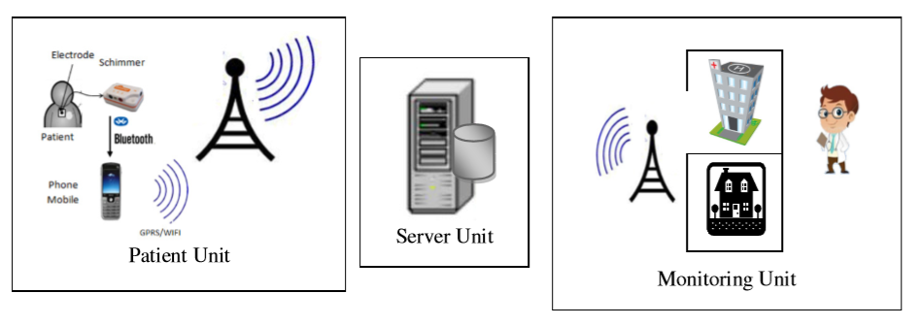

Figure 2. 3 Mobile Health System for Monitoring ECG signals architectural design[6].

### AliveCor

AliveCor is an American company that provide an ECG monitoring but not in real time and they only detect atrial fibrillation. The system is a mobile app that records the ECG signal analysis it and the user can send their records to the doctor via email.

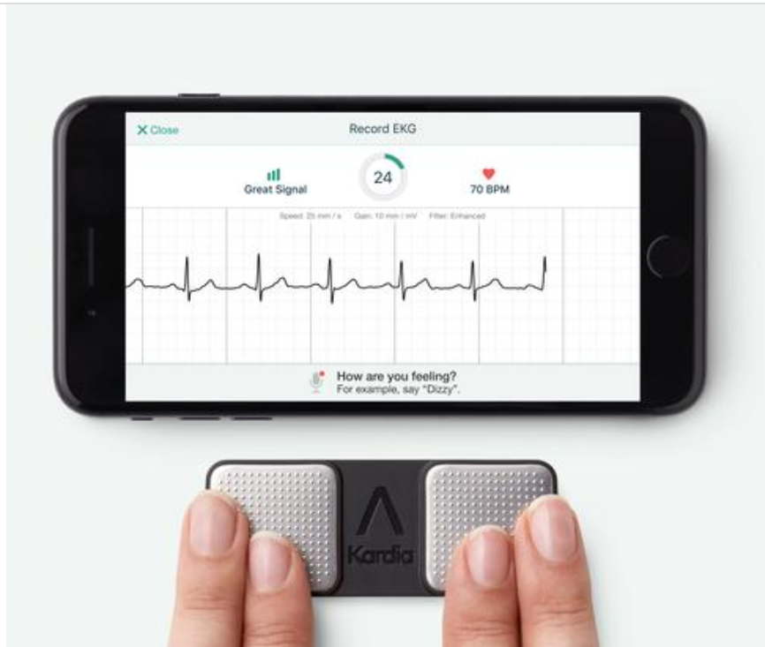

Figure 2. 4 AliveCor System[8]

## Body Guardian Heart

A heart monitoring system provided by preventice solutions allowing healthcare providers to monitor the users’ vital signs outside the clinics. Information from the Body Guardian Heart remote monitoring system is gathered and passed into a robust clinical data management system providing interactive access to patient clinical information by the physician and practice personnel. Based on the physicians' needs, a thorough set of reports can be created and reviewed on the PatientCare portal to track the patient’s progress.

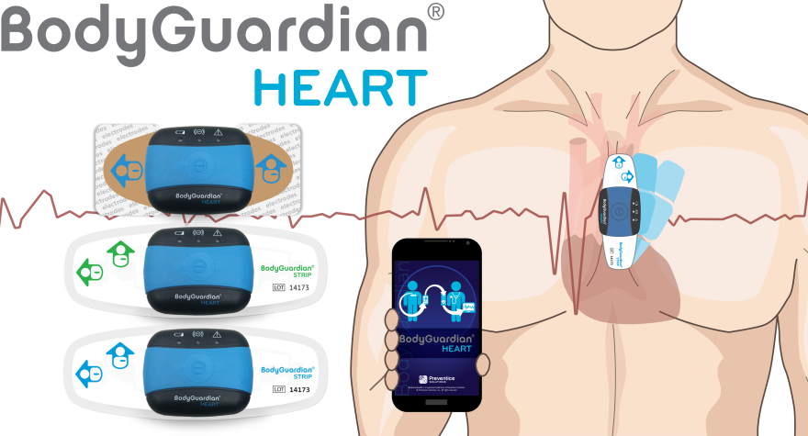

Figure 2. 5 Body Guardian System[9]

## QardioCore

Wireless continuous ECG monitor and heart rate , skin temperature, and respiratory rate. QardioCore accurately records and analyzes users' overall heart health who then can easily share their data with doctors and healthcare providers remotely.

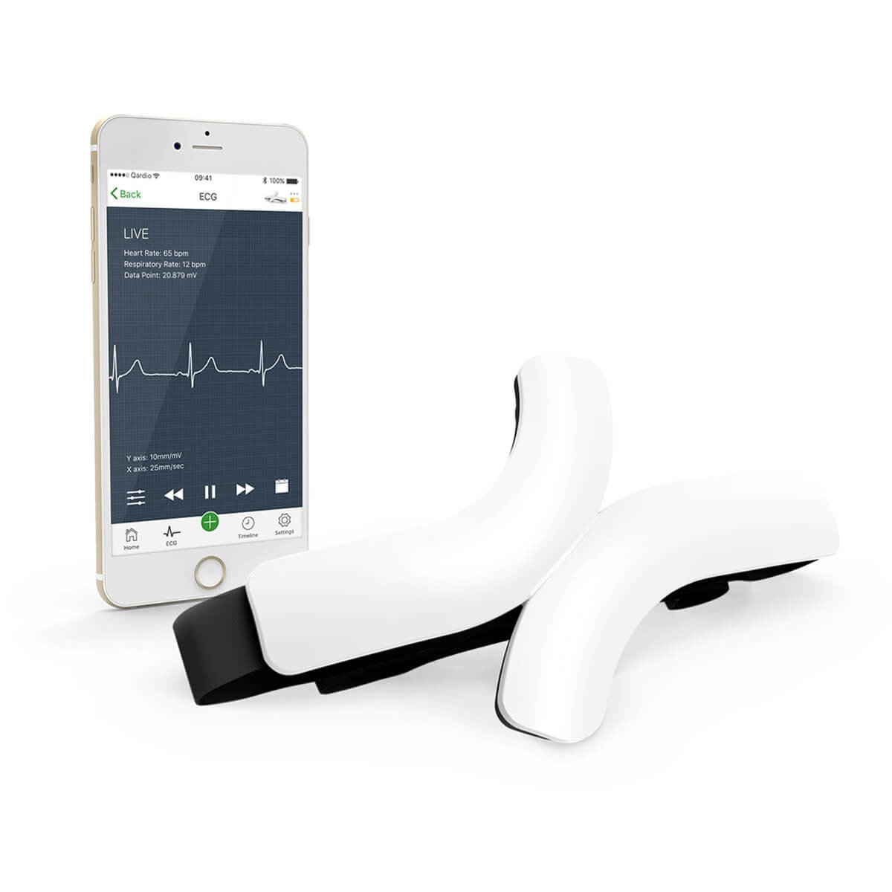

Figure 2. 6 QradioCore System.[10]

## CardioSecur

CardioSecur is a mobile ECG monitoring system that allows users view their ECG report on the smartphone and export it to pdf then send it to the doctor. CardioSecur measures 15 leads (viewpoints) of the heart a standard ECG only measures 12. It also can record complex arrhythmias and life-threatening circulation disturbances. The system cannot detect the arrhythmias but it can capture symptoms in ECG like strong palpitations or a racing heart, tightness or pain in the chest with radiation to the left arm, perspiration or cold sweats, and shortness of breath.

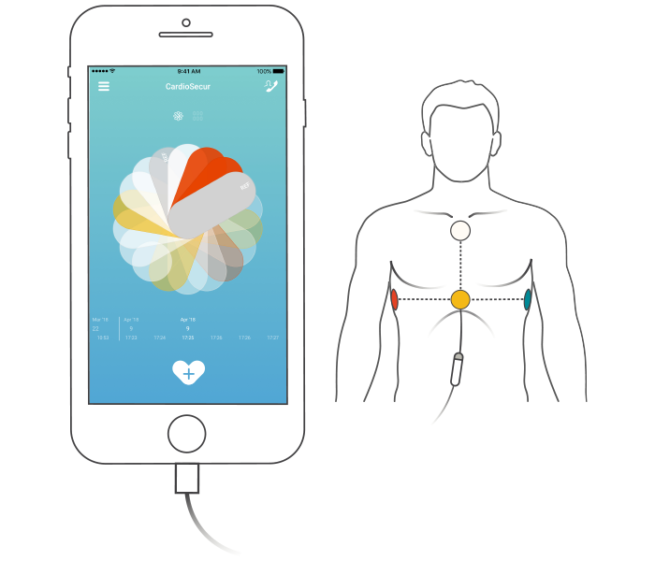

Figure 2. 7 CradioSecur System.[11]

## SHL Telemedicine

A 12 lead wireless ECG monitoring system allows users to access, view, and extract ECG any time and from everywhere. All the patients’ current and past ECG records stored on cloud and accessible from smartphones, tablets, or PCs. The system have center for experts to analyze the ECG signal with no machine intervention.

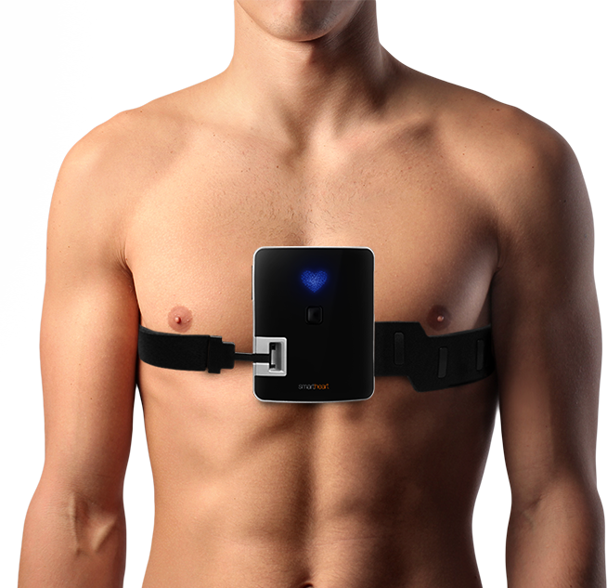

Figure 2. 8 Smartheartpro System.[12]

### Apple Watch Series4

Apple has introduced a new feature in its new Apple watch 2019. The system is designed to measure the ECG signal of the user and detect arrhythmia in it. After the detection of arrhythmia if exists the system asks the user to report a PDF file for his doctor and call emergency if he believes he/she has heart attack.

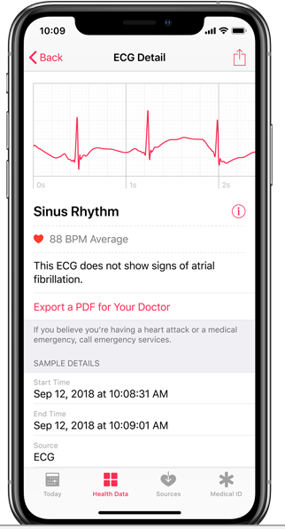

Figure 2. 9 Apple’s ECG app.[13]

## Summary

Depending on what have been discussed above, most of the systems are focusing on monitoring ECG without detecting arrhythmias kind –diagnosis- and for those how perform arrhythmia detection the do not provide real time monitoring. The added value of our system is the detecting of the arrhythmia kind which allows the system’s users to perform preventive actions depending on the diagnosing results in addition to the real time ECG monitoring.

**For more details and comparisons about the existing systems please review “Table B. 1 Competitors Analysis” in appendix B.**

# Chapter Three: System Analysis



## Introduction

Cardiac disease is one of the main causes of catastrophic mortality. Therefore, detecting the symptoms of cardiac disease as early as possible is important for increasing the patient's survival. We are introducing a new medical portable device that collects, analyzes and compares ECG signals and other vital signs in a high quality, low computational complexity and accurate detection.

In this chapter we will discuss the functional and nonfunctional requirements, the use case diagrams, sequence diagrams, design objectives and development methodology.

## Analysis of Existing Systems

Cardiac disease is one of the main causes of catastrophic mortality. Therefore, detecting the symptoms of cardiac disease as early as possible is important for increasing the patient's survival. We are introducing a new medical portable device that collects, analyzes and compares ECG signals and other vital signs in a high quality, low computational complexity and accurate detection.

### Document Review

ECG Portable System device is used to measure vital signs and to draw and compare ECG signals. The signals will be measured using Raspberry-pi computers in the pilot phase, and then they will be sent to a server to be analyzed and compared with normal signs. Analyzed data will be accessed from the mobile App by users and from a web portal by the specialists. In case of any deterioration, the system will send an SMS notification to the specialist and to the pre-defined person taking care of the patient.

The device will use the Internet of Things (IoT) recent technologies. It will operate based on data mining and machine learning models to analyze patterns of data. The first pilot phase will utilize Raspberry-pi 3 microcontroller and Healthy-Pi V3 HAT hardware. Raspberry-pi 3 microcontroller will drive the main sensors in the HealthyPi HAT. The second main component in system is HealthyPi. This component gathers data from the system.

### Data Collection Tools

Structured face-to-face interviews were used in order to collect primary data. Three

different questionnaires were developed and used for data collection in order to fulfill the research objectives:

1. Specialists/Doctors questionnaire: This questionnaire is used to perform interviews with cardiologists, specialists and doctors who are involved in such diseases.
2. Patients/Elderly People questionnaire: The second questionnaire is used to perform interviews with patients who suffer from cardiovascular diseases and elderly people who need such devices.
3. Professional and non-professional ambulatory centers questionnaire: This questionnaire focused on professional ambulatory emergency medical agencies that use or expected to use such device.

### Users Interviews & Observations

According to the interviewees, traditional ECG systems are doing the basic functionalities of monitoring the patients in hospitals. However, in many cases, patients face problems after discharge. At that time, doctors/specialists will no longer be able to take immediate actions.

Currently used traditional ECG systems are not portable, and that is making the monitoring process more difficult to both the doctors and the patients. On the other hand, traditionally used ECG systems are accurate and reliable.

Some systems which are already used have a memory enable users to save ECG history of patients.

Interviewed specialists, doctors, patients and elderly people are excited to use the system if it’s reliable and exist in affordable prices.

Interviewed patients expressed that they had to stay many times in hospitals under ECG monitoring, which was unnecessary, according to their doctors.

None of the interviewed had used similar products before, except Jenin hospitals manger. He answered that they use a centralized off-line system that records ECG signals for three days and has limited functionalities.

It was not easy to determine the expected price for the product. However, some patients and elderly people expressed their ability to buy from $100 to $200 to have it. The specialists’ point of view is that the system should be funded, since patients are not expected to buy extra money.

Interviewed specialists preferred to have some additional features along with ECG monitoring, such as detecting and monitoring vital signs (SPO2, blood pressure, sugar level…etc.).

Regarding the interviewed centers, some of them had many patients who had their heart attacks outside the hospital and were in a need for such device. Because of that, they will consider using such portable ECG device.

## System Requirements

The system requirements are the functionalities or the guidelines that the system should satisfy to meet the user needs. The system requirements are subdivided into two main categories which are the functional and nonfunctional requirements.

Functional requirements are the main & minimum functionalities that the system should meet.

Nonfunctional requirements are the recommended functionalities needed to make the system more sophisticated.

## Functional Requirements

1. Timely and distance diagnostic: Specialists and doctors will be able to read and diagnose each case in a highly efficient and fast manner and without the need to be physically near his patient.
2. Notification system: The device has a notification system that sends messages in a form of SMS to the pre-defined person taking care of the patient and also to the specialist of the patient.
3. Distance-monitoring system: Each doctor/specialist will have an ability to monitor many patients.
4. Use of detection technologies: The use of data science applications in data mining and the use of Raspberry pi hardware in the pilot phase is another key to success, since this technology is faster and more reliable than other traditional ones. (Our own detection algorithm)
5. Comparing ability: Given the feature of comparing the user signal with other saved patterns, the device will be able to analyze the signal and extract useful needed information.
6. Data storage: Having an online portal gathering the data of all users automatically will provide a better diagnostic experience. In addition to this, it will provide a bank of data for future research and development.

## Non Functional Requirements

* 1. Ease-of-use: The application associated with the device will be easy to be read by the user. As it provides a simple GUI interface, so interaction with the system will be intuitive.
  2. Small, lightweight and handheld device.
  3. Affordability: The price of the device is expected to be affordable. Moreover, the operational costs associated with the device are not high at all.
  4. Accuracy: The system is safety critical, which means that the readings must be very accurate for the proper functioning of the system.
  5. Security: Patient records can be accessed only by authorized users.

## Design Objectives

In this section we will describe system in the highest level of abstraction. The individual components of the system, what are the responsibilities, functions, aspects of each module, what kind of data storage is present and how the modules communicate.

## User Requirements

The user (patient) should be authenticated to access the system.

The user (patient) should be able to view his vital signs in real time manner.

The user (patient) should be monitored 24/7.

The user’s (patient) ECG, vital signs and relative data should be stored.

The user (patient) should get the results of the analysis of his signal via his mobile app.

The user (patient) should be alerted in case of arrhythmia detection.

The user (patient) can send and save records periodically.

The user (Doctor) should be authenticated to access the system.

The user (Doctor) should have web interface to monitor his/ her patients.

The user (Doctor) should be able to view the patient records.

The user (Doctor) should be able to report an error as a feedback to tell about something wrong in the analysis details or results.

## System Architecture

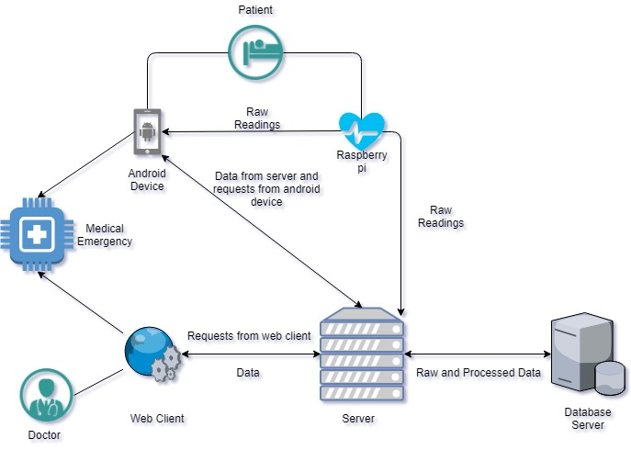

Figure 3. 1 Architectural design

## Development Methodology

The waterfall model is the software development methodology used to develop this system. This methodology consists of five linear phases (Requirements, Design, Implementation, Verification and Maintenance). Each phase was completely accomplished before moving on to the next one.

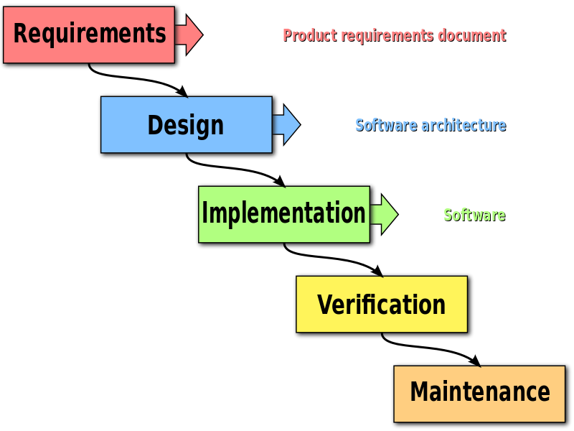

Figure 3. 2 Waterfall mode, progress flows from the top to the bottom.

## Use Case Diagrams

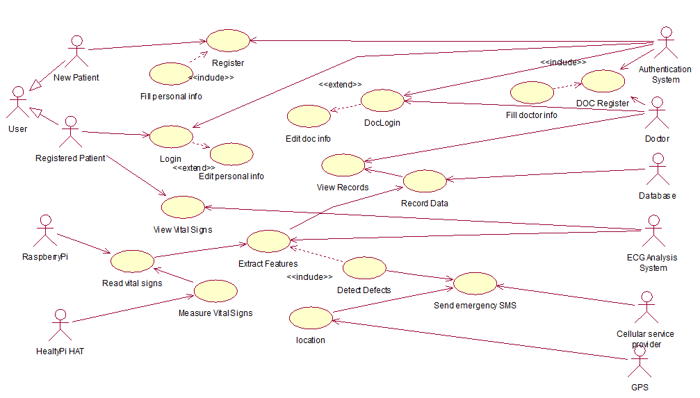

Figure 3. 3 Use case diagram

## Use Case Description (Detailed Use Cases)

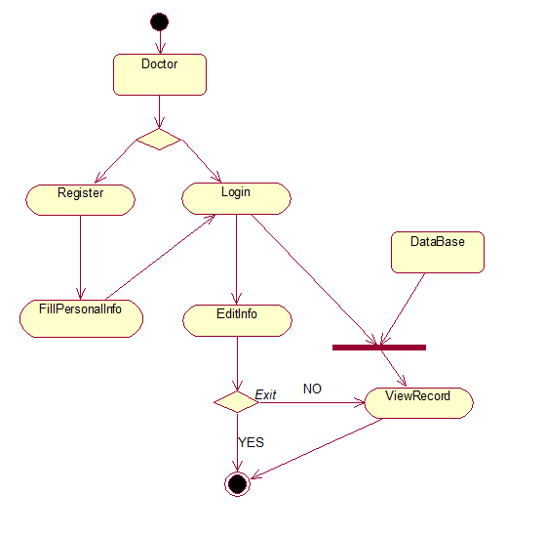

Figure 3. 4 Doctor’s use case description

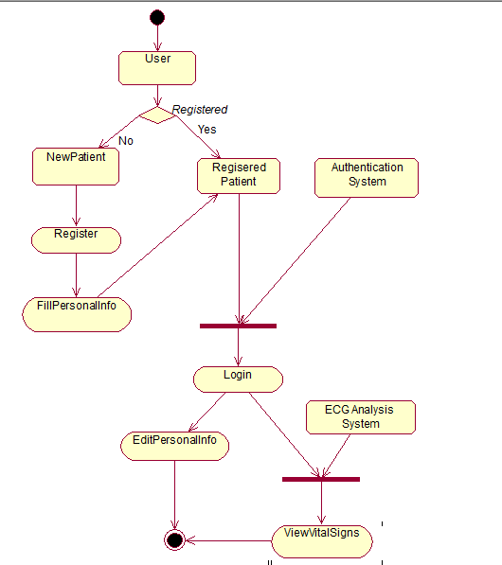

Figure 3. 5 Patient's use case description

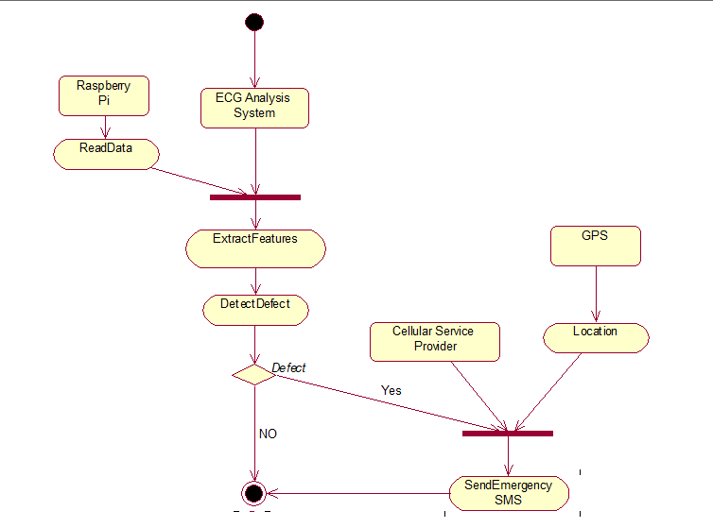

Figure 3. 6 ECG analysis use case description

## Sequence Diagram

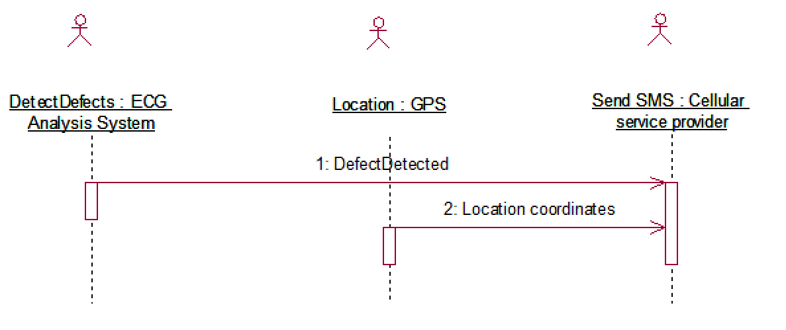

Figure 3. 7 Detect defects

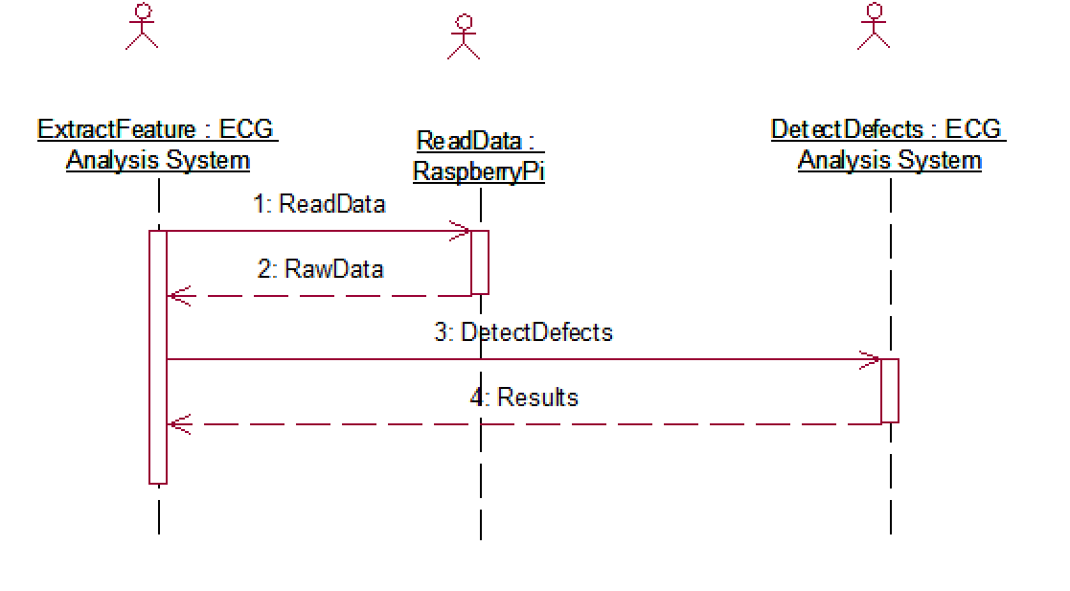

Figure 3. 8 Feature extraction

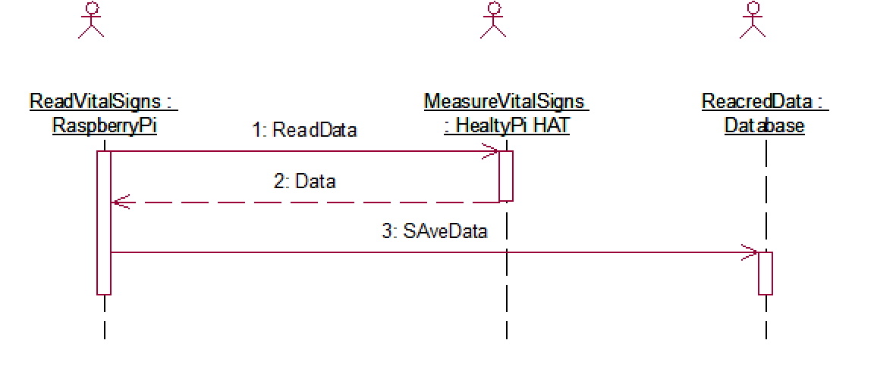

Figure 3. 9 Read vital signs

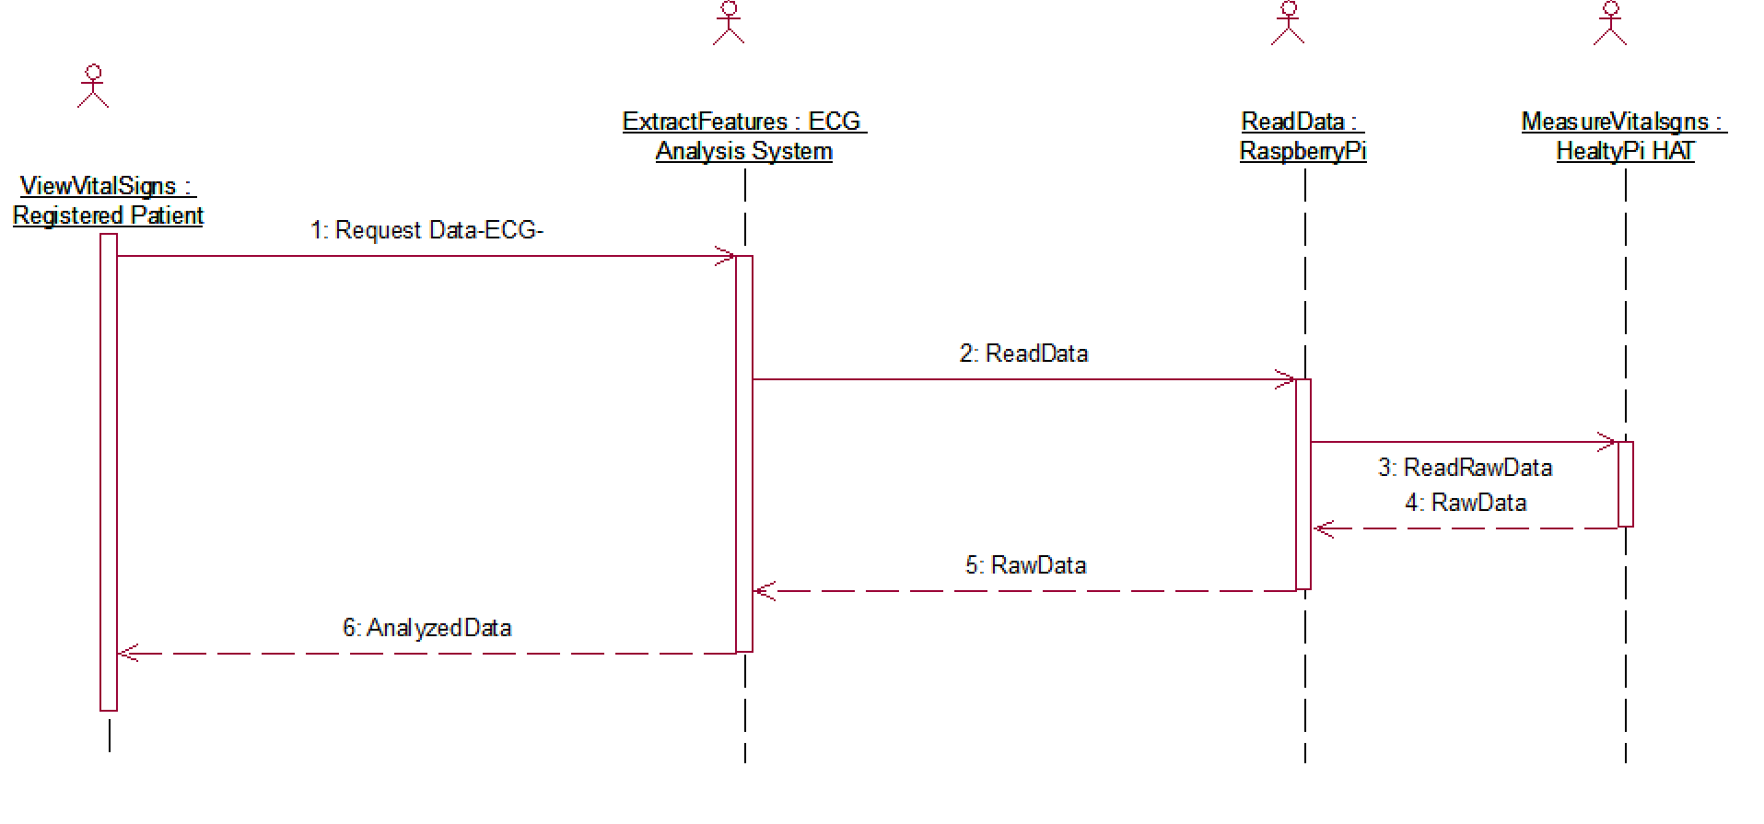

Figure 3. 10 View vital signs

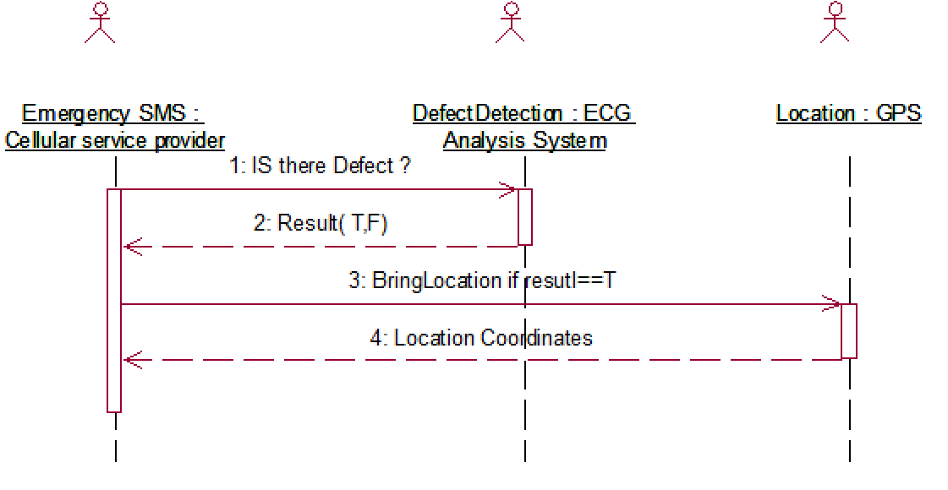

Figure 3. 11 Emergency Message

## Summary

In the previous diagrams, we used different modeling tools to represent the data flow, how the system work, also the interactions between the user and the system components was represented and the interactions between the objects themselves.

# Chapter Four: System Design



## Introduction

In this chapter we are going to discuss architecture, modules, interfaces and data for the system, the relations between them, and we give a detailed description of the hardware components used in the system.

## Class Diagram

In class diagram we are stating the structure of the system, the relationships between classes, objects, attributes and operations.

The system composed of seven main classes which are:

1. User: User Class is an abstract class generalized for patients and doctors and has an aggregation relationship with the class address where one user can have one or more addresses.
2. Address: the address class is a passive class that initiates the addresses of the users.
3. New patient: this class is used to initiate new users of the system and used to acquire the needed information.
4. Registered patient: this class used to provide the users (patients) with all the functionalities of the system dedicated for them.
5. Doctor: this class used to provide the users (Doctors) with all the functionalities of the system dedicated for them.
6. Record: class record is where all patients health information are passed for patients and doctors to be viewed each registered patient has one or more records and the doctor can view his patients’ records.
7. ECG: In this class all the processing of the ECG signals are performed.

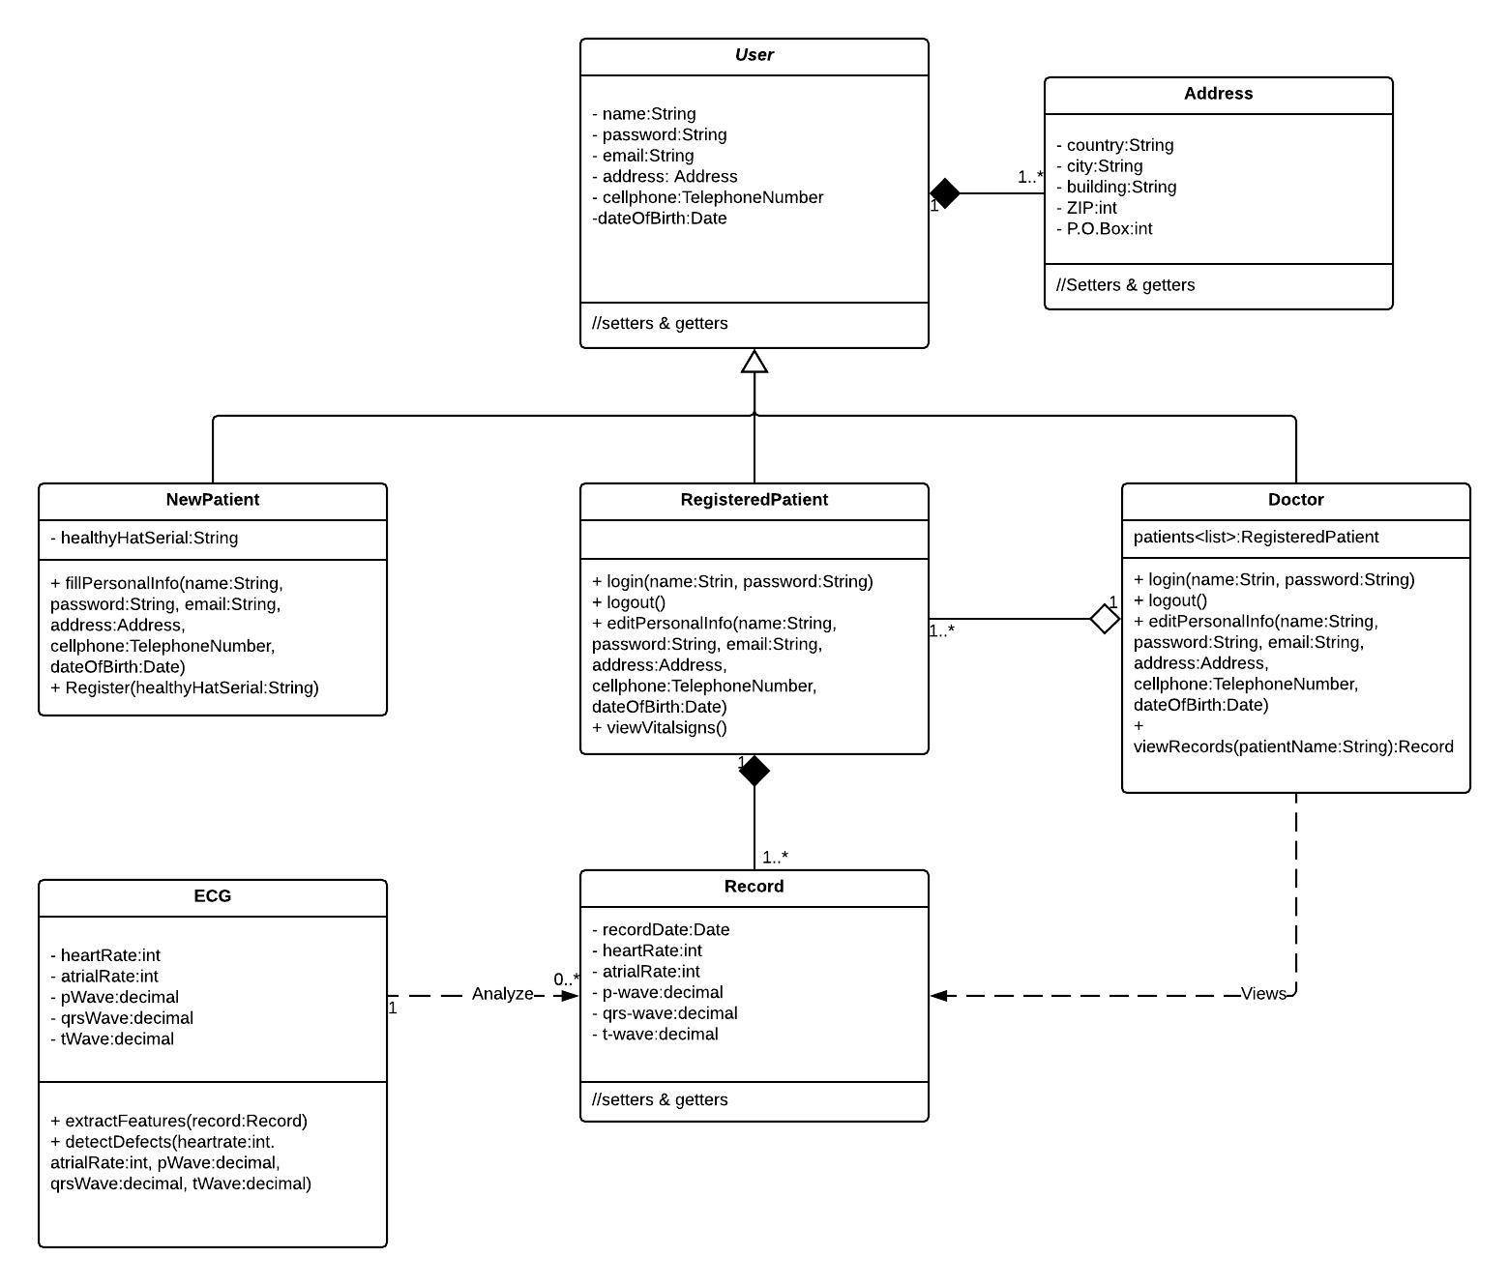

Figure 4. 1 System Class Diagram.

## Data base Design

The database of the system consists of four main tables which are:

1. Patient: the patient table has all the information needed for keeping track with patient this table has a one to one relationship (Buy) with the HealthyPi table,

one to many relationship (has) with Record table and many to one relationship has with the table Doctor.

1. Doctor: this table has all the information about the authorized doctors that access the system and their patients. The doctor can view a record.
2. HealthyPi Hat: this table has the information of the bought product of the system and their users.
3. Record: a weak entity because it cannot be without the attendance of the patient and the doctor.

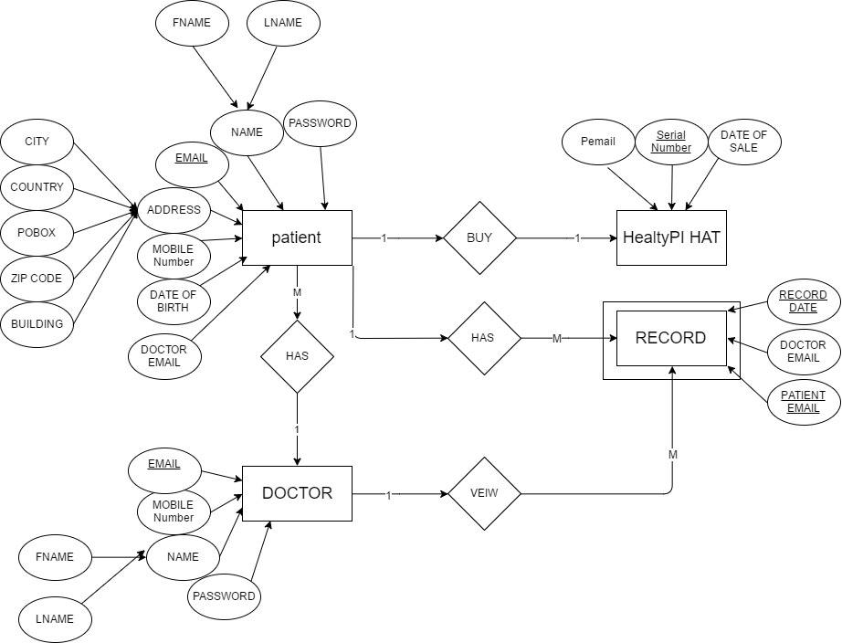

Figure 4. 2 System Database.

## Algorithms

The algorithm used in the system aimed to detect normal sinus rhythm (NSR) and atrial fibrillation (AFib). The algorithm basically counts the QRS, P and T wave in the ECG signal to extract indications about its status. If the signal is normal it will continually check the signal after a specific time period, otherwise the system will notify the user that AFib has been detected and he needs to review a doctor.

1. Detect QRS peaks.
2. Calculate the sample frequency of the signal.
3. Detect P and T peaks.
4. Count P and T peaks between every two QRS peaks in the signal.
5. Take average of Peaks.
6. Check the average of peaks.
7. If normal wait for the specified time.
8. Go to (a).
9. If not normal notify the user and the doctor.

A free open source python library was used to detect the QRS complex, p, and T waves, the algorithm was tested on the Massachusetts Institute of Technology (MIT-BIH Arrhythmia Database) and the results based on the kind of samples in this database which are 12 lead ECG read on 360 sample/ second. **More about the results are discussed in chapter 5.**

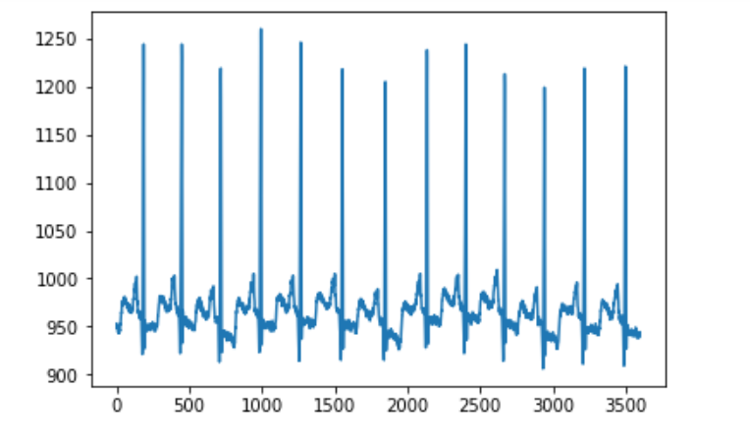

Figure 4. 3 Sample wave.

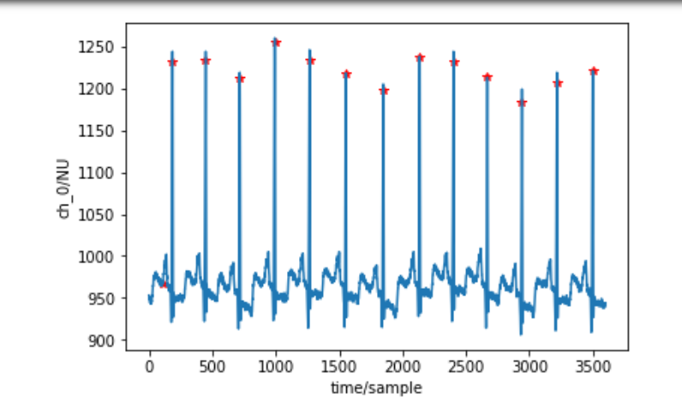

Figure 4. 4 QRS detection NSR.

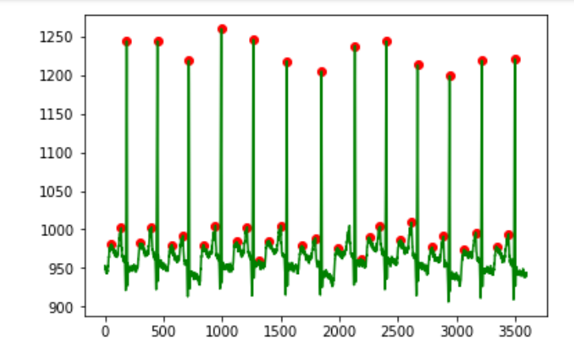

Figure 4. 5 P, QRS & T Peaks Detection NSR

## Interface Design

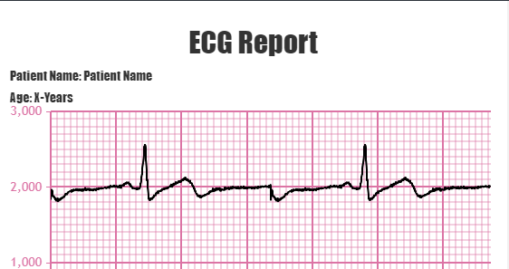

Figure 4. 6 Web Client interface.

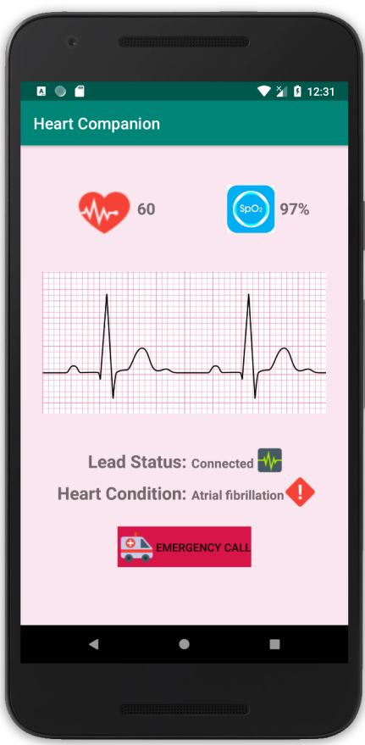

Figure 4. 7 MobileApp Interface

## Hardware

In this section we are going to present the hardware components used in the system and list the main characteristics and features.

### Hardware Components

1. Rasppberry-Pi Microcontroller.

We are using the raspberry-pi microcontroller to drive the main sensors in the HealthyPi HAT, which is powerful enough to get the job done without.

Here are the specs of the microcontroller: -

• SoC: Broadcom BCM2837.

• CPU: 1.2 GHZ quad-core ARM Cortex A53 (ARMv8 Instruction Set).

• GPU: Broadcom VideoCore IV @ 400 MHz.

• Memory: 1 GB LPDDR2-900 SDRAM.

• USB ports: 4.

• Network: 10/100 MBPS Ethernet, 802.11n Wireless LAN, Bluetooth 4.0.

1. Healthy-Pi V3 HAT:

Which is the most important component in our system, it gathers the data for the system to be processed, here are the main specs of the HAT: -

• ECG and respiration front-End: Uses the TI ADS1292R 24-bit analog front-end with SNR of 107 dB.

• Pulse oximetry: Uses TI AFE4400 Pulse Oximetry front-end with integrated LED driver and 22-bit ADC.

• Temperature: Uses Maxim MAX30205 digital body temperature sensor for skin temperature sensing.

• Main microcontroller: Atmel ATSAMD21 ARM Cortex M0 - compatible with Arduino Zero.

• Programmability: Arduino Zero Bootloader preloaded.

• Interfaces: Raspberry Pi 40-pin header (UART pins connected), USB CDC device, extra UART connector provided for connecting an external blood pressure module.

• IoT functionality: Can use the Raspberry Pi’s Wi-Fi interface to communicate with a TCP client for telemedicine applications or using an MQTT client for continuous logging applications.

• GUI Compatibility: Uses processing Java-mode (compiles on MacOS/Windows/Linux/Linux-ARM platforms).

• Firmware compatibility: Compiles with Arduino or Atmel Studio.

• Dimensions (board only): 65 mm x 56.5 mm x 6 mm.

• Weight: 100 g.

The wide spectrum of available sensors in the HAT enables us to monitor the most important vital signs, which makes our system function as a complete health monitoring system

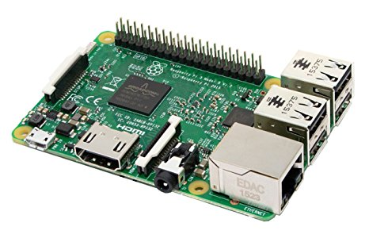

Figure 4. 8 Raspberry-Pi 3 Model B.

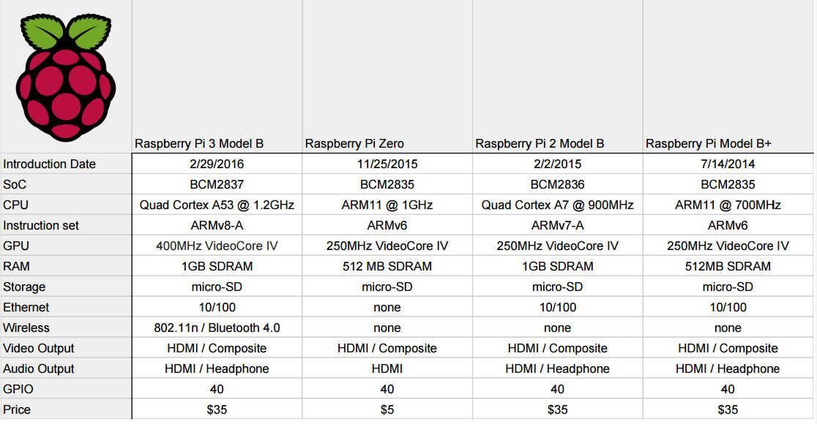

Figure 4. 9 Raspberry-Pi Models Comparison Table

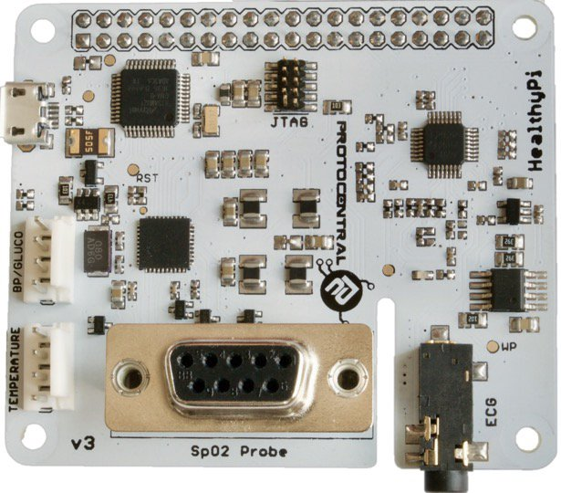

Figure 4. 10 Heakthy-Pi Module.

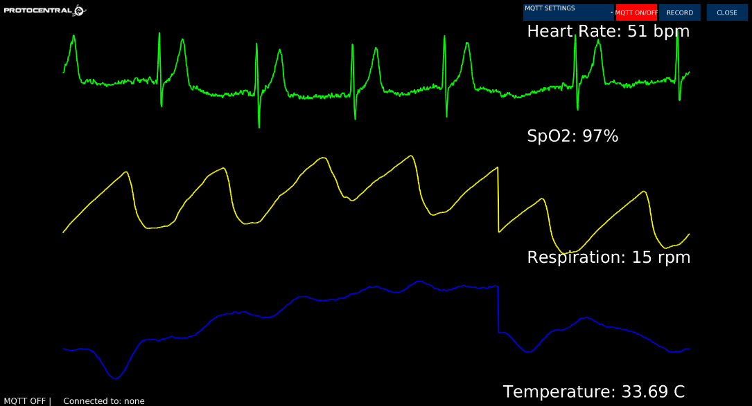

Figure 4. 11 Vital signs from Healthy-Pi HAT

## Summary

In this chapter we have discussed the main classes in the system as represented in the class diagram, the database schema and ERD, the web interface used by the doctor and the hardware components used in the system.

We can see that the most important role in the system is data gathering which is carried out by the raspberry-pi and the HealthyPi HAT.

# Chapter Five: Evaluation and Results

The normal Sinus rhythm (NSR) differs from Atrial Fibrillation (AFib) in the presence of P-wave, usually NSR has (p, T) waves between every QRS complex wave, while the AFib has only one wave between every two QRS waves which means average of two waves in the NSR and one wave in the AFib if we counted the waves in the previous signal.

An algorithm was developed to count the average of waves in an ECG signal, first we detect the QRS waves and after that we count every peak between each two QRS waves, and lastly we take the average of counted peaks over the QRS peaks, if the average was around 2 the wave considered to be normal, otherwise if it was around 1 it will be considered AFib rhythm. **For more about NSR’s and AFib’s see appendix A.**

The developed algorithm was tested on 283 NSR ECG waves and 135 Atrial Fibrillation (AFib) ECG waves from Massachusetts Institute of Technology (MIT-BIH Arrhythmia Database), the algorithm was able to detect correctly 100% of the NSR and AFib rhythms.

NSR rhythms must have two peaks (T, P) between each QRS Peaks while AFib rhythms have only one peak (T) between each QRS peaks because of the absence of the P wave.

After applying the algorithm we got the following results in Table.5 – The result in the table are samples all the results and algorithm code are in appendix E-.

|  |  |
| --- | --- |
| NSR ECG | Average peaks detected by the algorithm |
| NSR 0 | 2.00 |
| NSR 1 | 2.00 |
| NSR 2 | 2.00 |
| NSR 3 | 2.00 |
| NSR 4 | 2.00 |
| NSR 5 | 2.08 |
| NSR 6 | 2.07 |
| NSR 7 | 2.06 |
| NSR 8 | 2.05 |
| NSR 9 | 2.00 |
| NSR 10 | 2.04 |
| NSR 11 | 2.07 |
| NSR 12 | 2.07 |
| NSR 13 | 2.06 |
| NSR 14 | 2.09 |
| NSR 15 | 2.08 |
| NSR 16 | 2.08 |
| NSR 17 | 2.07 |
| NSR 18 | 2.12 |
| NSR 19 | 2.16 |
| NSR 20 | 2.18 |
| NSR 21 | 2.19 |
| NSR 22 | 2.22 |
| NSR 23 | 2.26 |
| NSR 24 | 2.28 |
| NSR 25 | 2.29 |
| NSR 26 | 2.28 |
| NSR 27 | 2.29 |
| NSR 28 | 2.30 |
| NSR 29 | 2.30 |

Table 5. 1 NSR average peaks (Samples).

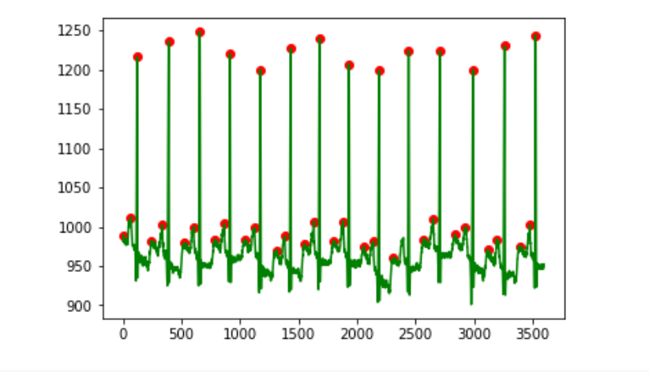

Figure 5. 1 NSR 3 peaks detection

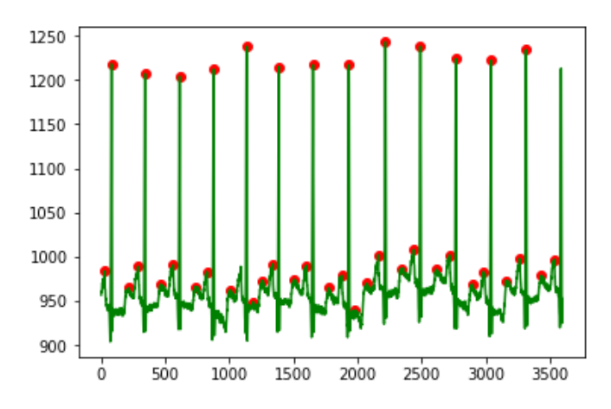

Figure 5. 2 NSR 4 peaks detection

|  |  |
| --- | --- |
| Atrial Fibrillation ECG | Average Peaks |
| AFib 0 | 0.50 |
| AFib 1 | 0.75 |
| AFib 2 | 0.83 |
| AFib 3 | 0.75 |
| AFib 4 | 0.80 |
| AFib 5 | 0.83 |
| AFib 6 | 0.85 |
| AFib 7 | 0.87 |
| AFib 8 | 0.83 |
| AFib 9 | 0.80 |
| AFib 10 | 0.81 |
| AFib 11 | 0.87 |

Table 5. 2 AFib average peaks.

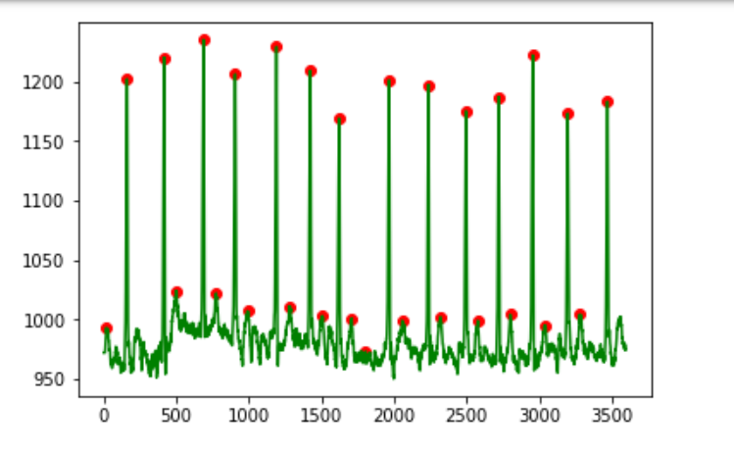

Figure 5. 3 AFib 0 Peaks Detection.

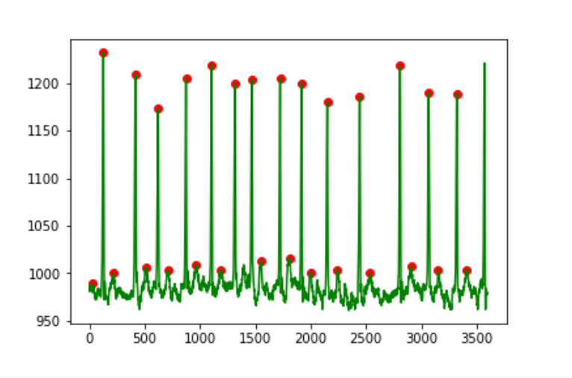

Figure 5. 4 AFib 2 Peaks Detection

# Chapter Six: Conclusions and Future Work

## 6.1 Conclusions

The system was able to satisfy the documented requirements data was transferred in real time in addition to monitoring the ECG signal and detecting the atrial fibrillation an arrhythmia that causes a blood clot which can transform to heart attack, strike or other complaints depending in where this clot blocks.

We have started with the moving the signal from the raspberry pi to the server, the first attempt was using Google’s firebase database, the latency results for that technology was not good enough.

The second approach was using a Node.js with socket.io, this arrangement provided better results because socket.io is built on web sockets, which provided robust connection between the raspberry pi and the server.

Socket.io was also used in the android application to get the readings from the raspberry pi in real-time.

## 6.2 Future Work

In future work we are planning to analyze and detect as much as possible of ECG arrhythmias and transform or project to a startup dedicated in heart health that provides customers with products keeps them safe and heathy.

# References

1. Ahamed, M. A., Hasan, M. K., & Alam, M. S. (2015, November). Design and implementation of low cost ECG monitoring system for the patient using smartphone. In Electrical & Electronic Engineering (ICEEE), 2015 International Conference (pp. 261-264). IEEE.
2. Gradl, S., Kugler, P., Lohmüller, C., & Eskofier, B. (2012, August). Real-time ECG monitoring and arrhythmia detection using Android-based mobile devices. In *Engineering in Medicine and Biology Society (EMBC), 2012 Annual International*
3. Roy, J. K., Deb, B., Chakraborty, D., Mahanta, S., & Banik, N. (2013). The wearable eletronic rescue system for home alone elderly-labview & arduino evaluation. *IOSR J. Electron. Commun. Eng*, *8*(6), 50-55.
4. <https://www.dicardiology.com/article/trends-and-advances-ecg-management-systems>
5. Patel, A. M., Gakare, P. K., & Cheeran, A. N. (2012). Real time ECG feature extraction and arrhythmia detection on a mobile platform. *Int. J. Comput. Appl*, *44*(23), 40-45.
6. Amour, N., Hersi, A., Alajlan, N., Bazi, Y., & AlHichri, H. (2015). Implementation of a mobile health system for monitoring ECG signals.
7. Kidd, P. S., Wagner, K. D., & Johnson, K. L. (1997). *High acuity nursing*. Appleton & Lange.
8. <https://www.alivecor.com/>
9. <https://www.preventicesolutions.com/technologies/body-guardian-heart.html>
10. https://www.getqardio.com/qardiocore-wearable-ecg-ekg-monitor-iphone/
11. <https://www.cardiosecur.com/>
12. <http://www.shl-telemedicine.com/>
13. https://www.apple.com/apple-watch-series-4/

# Appendices

## Appendix A: ECG Basics and Rhythm Interpretation

ECG: is the process of recording the electrical activity of the heart over a period of time using electrodes placed on the skin.

Normal ECG signal consists of three main parts:

* 1. P-wave: describes the atrial depolarization, all the P-waves look alike and one P-wave precedes every QRS-complex wave. If more than one P-wave precedes the QRS-complex heart block may be present.
  2. QRS-complex: describes the ventricular depolarization, its appearance varies with individual, not all 3 waves need to be present and all complex should look alike in the same lead.
  3. T-wave: describes ventricular repolarization, reversed or peaked T-waves indicate issues.
  4. R-R interval: represents the heart rate, constant R-R intervals represents regular rhythm and vice versa.
  5. P-R interval: represents the impulse traveling time from the atrium to ventricles, has a duration of .12-.20 second.
  6. Q-T interval: length of time for ventricles to depolarize and repolarize, has a duration of half the R-R interval.

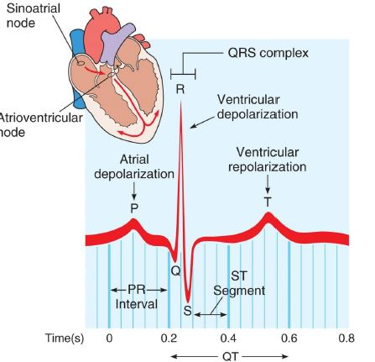

Figure A. 1 Normal ECG Wave and Intervals

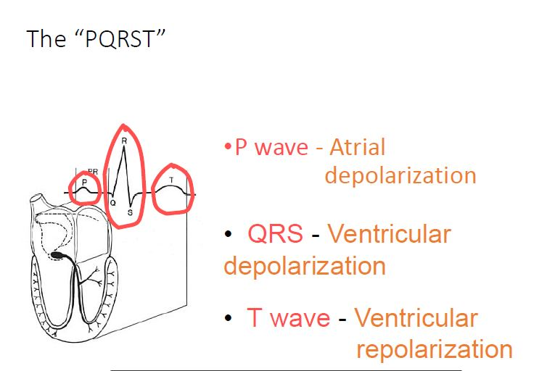

Figure A. 2 Representation of the meaning of each wave in ECG.

Atrial Fibrillation: abnormal heart rhythm caused by rapid and irregular beating of the atria and characterized by absent P-waves, irregular R-R interval, atrial rate >350 bpm.

Symptoms: Often this rhythm has no symptoms but sometimes there may be heart palpitation (pulse), fainting (lose consciousness for a short time), lightheadedness, Shortness of breath, and chess pain.

Risks or Complications: stroke, heart failure.

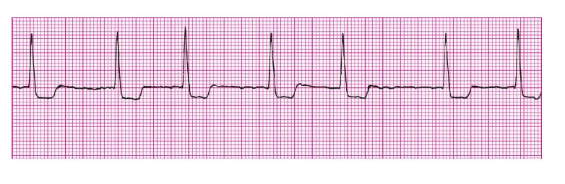Figure A. 3 AFib ECG

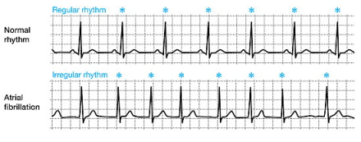

Figure A. 4 Comparison Between Regular Rhythm & Atrial Fibrillation

## Appendix B Business Plan

### Appendix B.1 Executive Summary

Cardiac disease is one of the main causes of catastrophic mortality. Therefore, detecting the symptoms of cardiac disease as early as possible is important for increasing the patient's survival. We are introducing a new medical portable device that collects, analyzes and compares ECG signals and other vital signs in a high quality, low computational complexity and accurate detection.

#### Appendix B.1.1 Objectives

Portable ECG System is a new medical wearable device that operates based on the IoT concepts. It provides the ability to real-time electrocardiogram (ECG) signal acquisition and analysis in order to detect arrhythmia and heart diseases. The device compares ECG data based on wavelet analysis and feature extraction. Additionally, this device will provide an integrated platform for patients as well as their supervising specialists.

The market for this business is very large due to the fact that there is a wide base of the benefited customers. This includes: 1) patients whose hearts could be monitored from home; 2) people who are prone to heart diseases; 3) elderly people; and 4) non-specialized clinics.

#### Appendix B.1.2 Mission

The mission of our Portable ECG System is three-fold, with each being as integral to our success as the next:

•Product Mission: Provide patients and other customers with the highest technology portable ECG device in a very high quality, reliability and accuracy.

•Community Mission: Enable early diagnosis of Cardiovascular Diseases (CVD), and thus reduce sudden death cases.

•Economic Mission: Decrease national and international treatment cost, and also economic growth of our business at profitable rates.

#### Appendix B.1.3 Keys to Success

There are several keys to success in our start-up company. These keys together formulate our competitive advantages. These include the following:

•Ease-of-read: The application associated with the device will be easy to be read by the user.

•Small, lightweight and handheld device.

•Timely and distance diagnostic: Specialists and doctors will be able to read and diagnose each case in a highly efficient and fast manner and without the need to be physically near his patient.

•Notification system: The device has a notification system that sends messages in a form of SMS to the pre-defined person taking care of the patient and also to the specialist of the patient.

•Distance-monitoring system: Each doctor/specialist will have an ability to monitor many patients at the same time.

•Use of modern technologies: The use of data science applications in data mining and the use of Raspberry pi hardware in the pilot phase is another key to success, since this technology is faster and more reliable than other traditional ones.

•Comparing ability: Given the feature of comparing the user signal with other saved patterns, the device will be able to analyze the signal and extract useful needed information.

•Data gathering: Having an online portal gathering the data of all users automatically will provide a better diagnostic experience. In addition to this, it will provide a bank of data for future research and development.

•Decrease the occupancy of beds at hospitals, due to the fact that some patients will be able to be monitored from home. This will provide better opportunities for other cases to be treated in a more efficient manner.

•Affordability: The price of the device is expected to be affordable. Moreover, the operational costs associated with the device are not high at all.

### Appendix B.2 Product

This section talks in details about our startup’s first product, which is the Portable ECG Device. It presents the description of the product and the used technology.

#### Appendix B.2.1 Product Description

ECG Portable System device is used to measure vital signs and to draw and compare ECG signals. The signals will be measured using Raspberry-pi computers in the pilot phase, then they will be sent to a server to be analyzed and compared with normal signs. Analyzed data will be accessed from the mobile App by users and from a web portal by the specialists. In case of any deterioration, the system will send an SMS notification to the specialist and to the pre-defined person taking care of the patient.

#### Appendix B.2.2 Technology

The device will use the Internet of Things (IoT) recent technologies. It will operate based on data mining and machine learning models to analyze patterns of data. The first pilot phase will utilize Raspberry-pi 3 microcontroller and Healthy-Pi V3 HAT hardware. Raspberry-pi 3 microcontroller will drive the main sensors in the HealthyPi HAT. The second main component in system is HealthyPi. This component gathers data from the system.

### Appendix B.3 Market Analysis

Understanding the market before launching a product is a main success factor. Thus, the following sections analyze the market and industry in details.

#### Appendix B.3.1 Industry Description and Outlook

According to the American Heart Association (AHA), arrhythmias afflict more than 4 million patients and results in approximately half a million deaths each year (only in the United States). Electrocardiography (ECG) measurements, which record and interpret cardiac electrical activity over time, are widely used to detect abnormal heart rhythms. Consequently, ECG interpretation is the best way to measure and diagnose arrhythmia, particularly conditions arising from damage to the conductive tissue that transmits electrical signals in the heart.

As a diagnostic tool, ECG had been around for a long time, and penetration of these systems in hospitals is very high. Despite its established nature, the market continues to evolve with new devices, including ECG monitoring systems at healthcare facilities; event monitors for subacute patient monitoring, which patients carry with them to record heart rhythm for short periods of time; implantable loop recorders that are surgically inserted into patients and can record heart rhythms for an extended period of time; and telemetry and ECG data management solutions.

The penetration of ECG monitors has resulted in growing demand for ECG data management solutions for collecting data and streamlining report generation. Many vendors are therefore adding an ECG data management component to their other IT products in an effort to increase the competitiveness of their technologies. Using this type of bundling solutions, customers can make just one purchase, eliminating the need to acquire a stand-alone ECG data management solution, and limiting sales of ECG data management solutions.

Although the market for ECG monitoring devices and solutions is well established, changes in device capabilities, customer demands and reimbursement, continue to reshape the landscape in this market.

#### Appendix B.3.2 Market Trends

The increasing prevalence of CVDs such as stroke and chronic respiratory diseases such as asthma along with the growth of the aging population are expected to increase the demand for wearable medical devices in general and portable ECD devices in specific. CVDs are estimated to cause approximately 19 million deaths by 2020. Asthma accounts for six to seven in every 1,000 deaths annually. The number of people above the age of 65 is expected to increase to approximately 1.6 billion by 2050.

People with chronic diseases such as asthma require constant ECG monitoring. Hence, they are adopting wearable medical devices. Which, in turn, help to reduce costs and the burden of hospital visits.

In addition to this, the increasing adoption of smartphones is driving the growth of the global wearable medical devices market. With the advent of smart wearables, the scope of remote monitoring has increased significantly. Wearable patient monitoring devices record the various vital signs of people such as SPO2, respiration and temperature. These devices generate a significant volume of data, which can be analyzed using smartphones. Many companies have introduced wearable medical devices that are compatible with smartphones to monitor heart rhythms, sleep, and calories.

To sum up, the market of wearable medical devices in general and portable ECG devices in specific are growing day by day.

#### Appendix B.3.3 Market SWOT Analysis

A standard, useful and informative tool of analyzing a potential market is SWOT analysis. This method is based on addressing the Strengths, Weaknesses, Opportunities and Threats of entering the portable ECG market.

#### Appendix B.3.3.1 Strengths

- As a startup business, we will have a fast transformation time to rapidly cope with changes in the industry.

- The medical devices industry is not sensitive to economic changes.

- The number of potential customers is increasing in our region.

#### Appendix B.3.3.2 Weaknesses

- There is a relatively high ranked competitor in the market, which forms a highly competitive market.

- Our time in the market is very short.

- The limited resources we have compared to our competitors, and the high investment costs needed in the beginning of the project in R&D.

#### Appendix B.3.3.3 Opportunities

- High rates of elderly people worldwide and high death rates caused by cardiac diseases.

- High commitment from healthcare organizations towards treating these cases.

3.3.4. Threads

- The thread of controlling the cost from another competitor(s).

- Technology fast changing in the market, and the speed to cope with these changes.

#### Appendix B.3.4 Market Segmentation

There are four main segments for our product, as follows:

•Home monitoring of heart diseases

This segment includes patients who could be monitored from their specialists and relatives from another place. Over 18 million yearly deaths worldwide are due to heart deterioration. In the Middle East, the proportion of all deaths due to CVD is estimated to be more than 40%. Studies from Lebanon and Syria have reported that CVD contributes to 60% and 45% of the total mortality, respectively. Furthermore, a high prevalence of CHD has been reported in several countries in the MENA region. The MENA region is also witnessing alarming rates of CVD risk factors exceeding those in developed countries. The World Health Organization (WHO) data has revealed a significant increase in the prevalence of CVD risk factors within MENA countries, especially obesity which is responsible for almost 30–40% of CVDs. As a result, monitoring heart and the other vital signs is very important for this segment.

•Home monitoring of elderly people

Elderly people are usually more prone to heart deteriorations. Thus, they will be a main segment of our product. The percentage of the population over the age of 65 in the Middle East and Northern Africa (MENA) is estimated at 4.7% (of a total population of 336 million) according to the World Bank 2012 report.

•Professional ambulatory emergency medical equipment

This segment includes ambulances, police vehicles, hospitals, clinics…etc. The number of primary healthcare centers in Palestine, for example, is more than 740 centers, according to the Palestinian Health Information Center (2018).

•Non-professional emergency medical equipment

This includes school clinics, airlines, entertainment and creation centers…etc. This segment will consider the device as an affordable solution to be used if any health problem occurs. In addition, the scale of this segment is high and wide.

#### Appendix B.3.5 Marketing Strategies

Several marketing strategies will be used for introducing the device. One of these strategies is to push the device into the market through the cardiologists. Cardiologists will play a key role in convincing patients with the importance of the device and its benefits. The second marketing strategy is selling the device through medical distribution companies. Moreover, insurance companies can promote the use of the product, especially in the high-risk places, such as recreation centers, schools…etc.

#### Appendix B.3.6 Competitors Analysis

| Competitor Name | Used Technology | Price | Producer Country | Production Year | Targeted Customers | Main Strengths | Main Weaknesses |
| --- | --- | --- | --- | --- | --- | --- | --- |
| AliveCor | * IoT * Mobile Application * ECG finger sensors * Cloud Platform. | $100 | United States | 2011 | * People at risk * Normal people * Elders | 1. Can be integrated with apple watch 2. Detect normal heart rhythm or AFib, 3. Unlimited cloud storage of EKG recordings 4. Remote Patient Monitoring 5. Portable 6. Easy to use 7. Associated with a mobile app 8. Available Online | 1. Not real time 2. No Arrhythmia detection for other diseases |
| Preventice Solutions  “body-guardian-heart” | * IoT * Mobile Application * Centralized Cloud Platform | Not Ava. | United States | 2007 | * People at risk * Elders | 1. Constant connection between patients and their care teams “real time” 2. Records heart rhythm, ECG, respiratory rate and activity 3. Rhythm monitoring: Ambulatory ECG for arrhythmias, including Atrial Fibrillation, Tachycardia, Bradycardia, Pause, and others 4. Symptoms notification 5. Portable 6. Easy to use 7. Associated with a mobile app 8. Online Availability | 1. No user interaction |
| QardioCore | * IoT * Mobile application * ECG sensors * Centralized Cloud Platform, * Advanced detection * Algorithm | $125 | United States | 2012 | * Athletics * People at risk * Elders | 1. Accurate electrocardiograph 2. Doctor/patient connection 3. Other vital signs measurement 4. Portable 5. Easy to use. 6. Associated with a Mobile App | 1. Not real time 2. No arrhythmia detection |
| APPLE WATCH (series 4) | * Apple watch application, * ECG sensors, * Centralized Cloud Platform, * Advanced detection Algorithm | $500 | United States | 2018 | * All people | 1. doctor/patient connection. 2. Other vital signs 3. AFib detection 4. Associated with a Mobile App 5. Online Availability | 1. Not real time  2. No arrhythmia detection |
| CardioSecur | * IoT * Mobile application * ECG sensors * Centralized Cloud Platform * Advanced detection algorithm | Normal users:  $115  +  $12 monthly  ---------  Physicians:  $230  +  Monthly:  $12 | Germany | 2008 | * People at risk * Elders | 1. Share ECG report with physician 2. View your ECG report on your smartphone at any time 3. Easily export ECG report as a PDF 4. Measures 15 leads, a standard ECG only measures 12 5. Personalized analysis by comparing your ECG reading to your [reference ECG](https://www.cardiosecur.com/) 6. Recognize recurrent symptoms after being treated for an arrhythmia and prevent stroke 7. Associated with a Mobile App 8. Online Availability | Not real time |
| Chinese ECG systems producers | * Advanced signal processing system * Powerful Hardware capabilities | $200-$1500 | China | Varies | * Patients at hospitals * clinical institutes | 1. Monitor ECG signal 2. Accurate 3. Associated with a Mobile App 4. Online Availability | 1. Not real time  2. No arrhythmia detection |
| Smartheartpro  SHL Telemedicine | * IoT * Mobile application, * ECG sensors, * Centralized Cloud Platform. | Not announced | Israel | 1987 | * People at risk * Elders | 1. Accurate electrocardiograph 2. doctor/patient connection. 3. Access, view, and extract ECG reports in seconds  any time and from everywhere in a secured way. 4. lead ECG device. 5. Subscription to ECG review service at SHL Telemedicine. 6. Associated with a Mobile App 7. Online Availability 8. Portable 9. Easy to use | 1. Not real time,  2. No in app arrhythmia detection  3. Sometimes it’s hard to wear it and take the right position. |

Table B. 1 Competitors Analysis

#### Appendix B.3.7 Competitors Analysis Results

Compared to the above listed competitors, we notice that our ECG system uses the following technologies: Sensors, Web client, Android application and Centralized Cloud Platform.

It deals with four main segments as mentioned before, and it has the following strengths over many of its competitors:

1) Real time monitoring.

2) patient/doctor Connection.

3) Arrhythmia detection algorithm.

4) Easy to use.

5) Emergency calls in risk situations.

6) Associated with a Mobile App.

#### AppendixB.3.8 Environment Analysis (Porter’s Five Forces)

Porter’s model is based on the insight that a corporate strategy should meet the opportunities and threats in the organization’s external environment. Especially, competitive strategy should base on an understanding of industry structures and the way they change. Porter has identified five competitive forces (as shown in Figure 1 below) that shape every industry and every market. Such model is very helpful in startup businesses as well. The five forces determine the intensity of competition and hence the profitability and attractiveness of an industry.

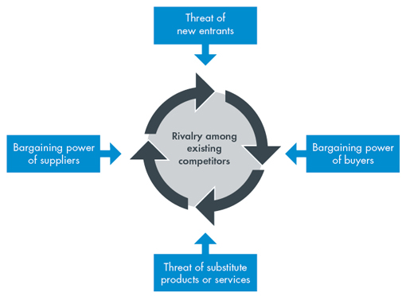

Figure B. 1 Porter’s Five Forces Model

The Five Competitive Forces as applied to our project are described as follows:

#### Appendix B.3.8.1 Buyers: Bargaining power of buyers

Due to the fact that customers have different options similar to our product, they have a high bargaining power. On the other hand, the differentiated features in our product decreases this power and improves our competitive edge at this factor. In addition to this, switching between the products needs some efforts, which also decrease the bargaining power of buyers.

#### Appendix B.3.8.2 Suppliers: Bargaining power of suppliers

When operating in mass production, the ability to outsource manufacturing the product is relatively easy. This is because the IT industry is not controlled by few firms. However, the need for a manufacturer that follows the high technology we are using will be challenging in order to maintaining a high level of quality.

#### Appendix B.3.8.3 Potential Entrants: Threat of new entrants

Due to the fact that the number of the current key players in the portable ECG system’s market is not that high, and the trendy technology we are using, threat of new entrants is relatively high. Moreover, the capital requirements in this field are also high. On the other hand, the R&D needed to achieve to exceed the quality, price and functionalities in the product make the entry difficult at some extent.

#### Appendix B.3.8.4 Substitutes: Threat of substitutes

As per the IT industry estimates, the threat of new substitutes is always high. Technology is growing day by day and the growth in data mining and machine learning specifically is growing high.

#### Appendix B.3.8.5 Industry competitors: Segment rivalry

The rivalry becomes more competitive through globalization of technology. The competitive varies from one to another. However, there is no concentrated market share for a single supplier in the market.

### Appendix B.4 Strategy and Implementation

Our strategy is to penetrate the consumer markets by offering our device in the most suitable and logical locations. The product will first penetrate the MENA region market since it’s one of the most demanding markets and among the least who has such technological devices and solutions. Our strategic priorities are:

•Providing customers with a high-quality device at an affordable price;

•Contributing to the medical industry and providing a solution that saves more lives.

#### Appendix B .4.1 Sales Strategy

To maximize revenue, we will utilize our market niche in marketing our product. This also involves our competitive price through offering the product at prices lower than our competitors.

We have set up a target sales plan targeting MENA region at 300 products at the first year, at a price of $140 per product and maintenance fees (subscription fees) of $5/month with an expected retention rate of %70. Moreover, the products will also generate promotions revenue through marketing pharmaceutical products at an average of $100 monthly.

#### Appendix B .4.2 Advertising and Promotion Strategy

We plan to promote our product to the market through hospitals and clinics. Exhibitions are also seen as the most direct way of creating awareness of our product to health representatives. Advertisements of our product will be placed in some of the leading medical journals and magazines in the region. Moreover, we will provide a %5 commission for selling the product.

#### Appendix B .4.3 Milestones

The table below lists our milestones and outlines the major events that will promote the success of our start-up. Our Key Performance Indicators (KPIs) will be used to monitor our success and our alignment to strategy.

|  |  |
| --- | --- |
| Milestone | Milestone Date |
| Minimum Viable Product (MVP) | 1/6/2019 |
| Private Beta Launch/Production | 1/9/2019 |
| Key Hire | 1/11/2019 |
| Start-up Ad Campaign | 1/4/2020 |
| Public Beta Launch/Production | 1/9/2020 |

Table B. 2 Mile Stones & Outline.

#### Appendix B.4.5 Business System and Organization

#### Appendix B.4.5.1 Management Team

A high entrepreneurial-spirit team composed of three students of Arab American University is running the startup. The integration between the team members in terms of background and experience is a very important factor in the success of the startup. The following table lists the owners of the starup, the background and experience for each of them, in addition to their associated tasks in the project.

|  |  |  |
| --- | --- | --- |
| **Team Member** | **Background and Experience** | **Associated Tasks** |
| Abdulsalam Mansour | Mansour is studying computer systems engineering in the Arab American University. His specialization in the IT field is Mobile Apps Development, and he has dedicated his efforts in the past year to master this specialization.  He started this by acquiring Udacity's nanodegree in Android Development.  He is also familiar with basic backend programming and networking, he has worked on many projects in these areas | Mansour will be the CTO of the company, he is the guy who handles all the technical stuff!  His main role in the ECG Analysis System Project is to handle the system design tasks, which include building the code for communicating between the sensor kit and the server.  He also has created the android app that displays the recorded data from the Sensors and made sure that all information are accessible by the user in real time. |
| Mokhles Naghnagheah | Naghnagheah holds a Bachelor’s degree in Computer Systems Engineering from Arab American University. He has a common knowledge in networking protocols TCP/IP. Naghnagheah is also familiar with working with different programming languages such as Java, C++, in addition to working with different web platforms such as ASP.NET framework, and common knowledge of some scripting languages such as JS and PHP. Moreover, Naghnagheah is familiar with the most common markup languages such as HTML, and CSS, he has a basic knowledge of data structures, management of databases and familiarity with working with SQL, and android development platform. | Naghnagheah is in charge of the technologies of handling the processed data coming from the server unit and presenting it on a web page in a standard form that enables cardiologists of reading the signals, and also developing and maintaining the web page of the system. He is also responsible of managing and coordinating the project components and insuring the integration of all these components so that the whole system well accomplishes its main functionalities. In addition to that, Naghnagheah in responsible of reviewing the status of the project, linking the technical work so that it meets its business plan’s objectives and perform corrective actions in case of any deviation from the business plan. |
| Ali Sawahreh | Sawahreh is a Computer System Engineering graduate from Arab American University, who is interested in artificial intelligence and web development. He is a junior software developer with basic skills in applications development, front‐end, and database development. Sawahreh is a self-driven and highly-motivated developer who has knowledge in object‐oriented programming languages. Currently, he is working on Artificial Intelligence Engineering Degree from SimpliLearn. | Sawahreh is working on the arrhythmia detection algorithm, studying the ECG signals and working on it trying to figure out a sufficient algorithm to detect as many as possible of arrhythmias using the powerful language python |

Table B. 3 Management Team

#### Appendix B.5.2 Personnel Plan

In the next three to five years, our startup is expected to employ and contract technical and managerial staff as indicated below for each year:

|  |  |  |  |
| --- | --- | --- | --- |
| **Job Title** | **Number of Staff** | | |
| **Year 1** | **Year 2** | **Year 3** |
| **Owners** | 3 | 3 | 3 |
| **Administration Officer** | 0 | 1 | 2 |
| **R&D Engineer** | 1 | 3 | 8 |
| **Technical Specialist** | 0 | 1 | 4 |
| **Total** | **4** | **8** | **17** |

Table B. 4 Employees.

#### Appendix B.5.3 Organizational Structure

Below is the expected organizational structure.

Figure B. 2 Organizational Structure.

## Appendix C: Market Research

The purpose of the market research is to gather data on users, customers and potential customers to have an understanding of the market. The collected data aids business decision making. This, therefore, reduces the risks involved in making strategic decisions.

### Appendix C .1 Data Collection Tools

Structured face-to-face interviews were used in order to collect primary data. Three different questionnaires were developed and used for data collection in order to fulfill the research objectives:

1) Specialists/Doctors Questionnaire: This questionnaire is used to perform interviews with cardiologists, specialists and doctors who are involved in such diseases.

2) Patients/Elderly People Questionnaire: The second questionnaire is used to perform interviews with patients who suffer from cardiovascular diseases and elderly people who need such devices.

3) Professional and non-professional ambulatory centers questionnaire: This questionnaire focused on professional ambulatory emergency medical agencies who use or expected to use such device.

Data collection tools are shown at the end of the appendix.

### Appendix C .2 Interviews Implementation

Due to logistics, time restrictions, cost and nature of this market research, each data collection tool was implemented on two different interviewees. The same researcher performed the data collection in order to improve the same procedures in semi-structured interviews. Date collection tools were implemented in December, 2018.

### Appendix C .3 Interviews Results

- According to the interviewees, traditional ECG systems are doing the basic functionalities of monitoring the patients in hospitals. However, in many cases, patients face problems after discharge. At that time, doctors/specialists will no longer be able to take immediate actions.

- Currently used traditional ECG systems are not portable, and that is making the monitoring process more difficult to both the doctors and the patients. On the other hand, traditionally used ECG systems are accurate and reliable.

- Some systems which are already used have a memory enable users to save ECG history of patients.

- Interviewed specialists, doctors, patients and elderly people are excited to use the system if it’s reliable and exist in affordable prices.

- Interviewed patients expressed that they had to stay many times in hospitals under ECG monitoring, which was unnecessary, according to their doctors.

- None of the interviewed had used similar products before, except Jenin hospitals manger. He answered that they use a centralized off-line system that records ECG signals for three days and has limited functionalities.

- It was not easy to determine the expected price for the product. However, some patients and elderly people expressed their ability to buy from $100 to $200 to have it. The specialist’s point of view is that the system should be funded, since patients are not expected to buy extra money.

### Appendix C.4 Interviews’ Questionnaires

**Interview Questions for Specialists/Doctors**

Interviewee Name: ____________________________.

Company/Hospital Name: __________________________.

Job title: __________________________.

1. What challenges do you face using traditional ECG systems?
2. Would you use a portable ECG to monitor your patients?

If yes, what are the most important features you want to have in this device?

1. At what price would you buy this product?
2. Have you ever tried using such device before? Yes/ No.

If yes, what is the device? __________________________________.

**Interview Questions for Patients/Elderly people**

Interviewee Name: ____________________________.

Disease Name: __________________________.

1. Have you ever slept in a hospital just to monitor your heart and vital signs?
2. Would you use a portable ECG to monitor your health at home?

If yes, what are the most important features you want to have in a portable ECG device?

1. Have you ever felt being at risk because of a late response to a heart deterioration?
2. At what price would you buy this product?
3. Have you ever tried using such device before? Yes/ No.

If yes, the device is: __________________________________.

**Interview Questions for Non-professional clinics  
(in schools, creation centers…etc.)**

Interviewee Name: ____________________________.

Company Name: __________________________.

Job title: __________________________.

1. Have you ever had an accident at your company that urged an immediate heart diagnostic?
2. Would you consider using a portable ECG at your company? If yes, would this increase the safety procedures at your workplace?
3. What are the most important features you want to have in this device?
4. At what price would you buy this product?
5. Have you ever tried to use such device before? Yes/ No.

If yes, the device is: __________________________________

## Appendix D: Financial Plan

The financial picture of the project is quite promising. The process requires a high talent and the financial investment in its employees will be one of the differentiators between it and other competitors in the market. The attached Excel Sheet (Financial Plan) illustrates the financial plan for the first’s operations year.

Link to the financial plan:

https://1drv.ms/f/s!AohSC_6A3LPMkiTeOGzIixcOJY5I

## Appendix E: Code & Results

All codes and results are in the following link:

https://1drv.ms/f/s!AohSC_6A3LPMkh8aOE_ri7th2Y_1